|  |  |  |  |  |  |  |  |  |  |  |
| --- | --- | --- | --- | --- | --- | --- | --- | --- | --- | --- |
| **Test Case ID** | | ARR_001 | **Test Case Description** | | Calculates the income, tax amount and netpay for the user | | | | | |
| **Created By** | | Ali AL-Salihi | **Reviewed By** | |  | | **Version** | | 1.0 | |
|  |  |  |  |  |  |  |  |  |  |  |
| **QA Tester’s Log** | | N/A | | | |  |  |  |  |  |
|  |  |  |  |  |  |  |  |  |  |  |
| **Tester's Name** | |  | **Date Tested** | | 2020/08/21 | | **Test Case (Pass/Fail/Not Executed)** | | Pass | |
|  |  |  |  |  |  |  |  |  |  |  |
| **S #** | **Prerequisites:** | | |  | **S #** | **Test Data** | | | | |
| 1 | The user must be informed to enter the name "Please enter your name:" | | |  | 1 | 18200 | | | | |
| 2 | The user must be informed to enter the annual salary " Please enter your annual Salary:" | | |  | 2 | 18201 | | | | |
|  |  | | |  | 3 | 37000 | | | | |
|  |  | | |  | 4 | 37001 | | | | |
|  |  | | |  | 5 | 90000 | | | | |
|  |  | | |  | 6 | 90001 | | | | |
|  |  | | |  | 7 | 180000 | | | | |
|  |  | | |  | 8 | 180001 | | | | |
|  |  |  |  |  |  |  |  |  |  |  |
| **Test Scenario** | Calculates the annual salary. | | | | | |  |  |  |  |
|  |  |  |  |  |  |  |  |  |  |  |
| **Step #** | **Step Details** | | **Expected Results** | | **Actual Results** | | | **Pass / Fail / Not executed / Suspended** | | |
|
| 1 | The user must be informed to enter the name | | "Please enter your name:" | | As expected | | | Pass | | |
| 2 | The user must be informed to enter the annual salary | | " Please enter your annual Salary:" | | As expected | | | Pass | | |

*Provide screenshots to support your testing and to cover the above cases.*

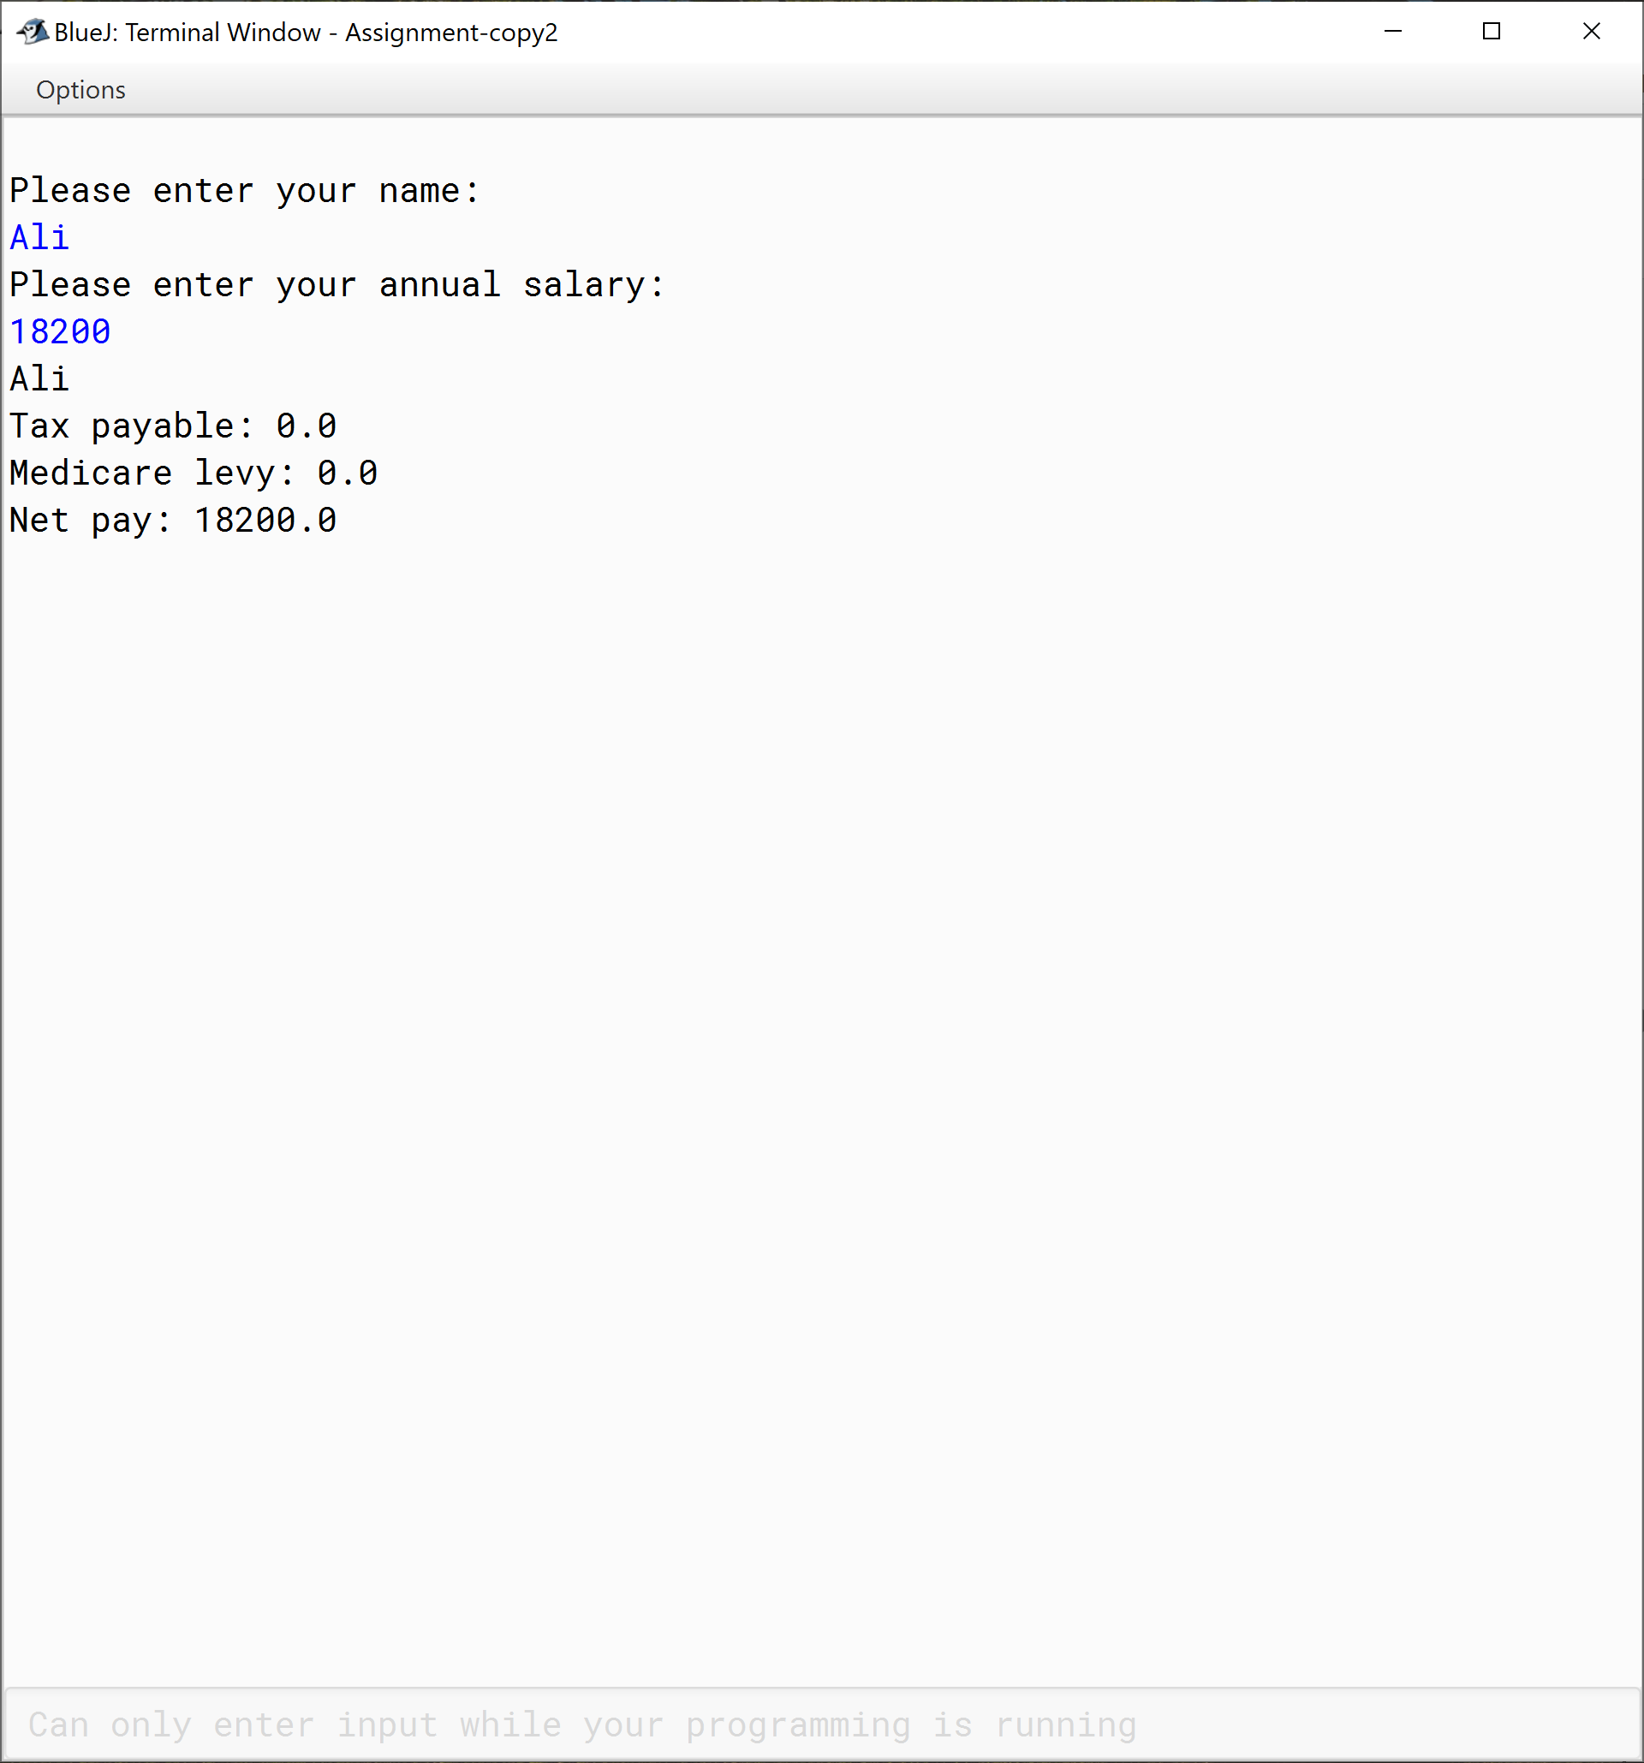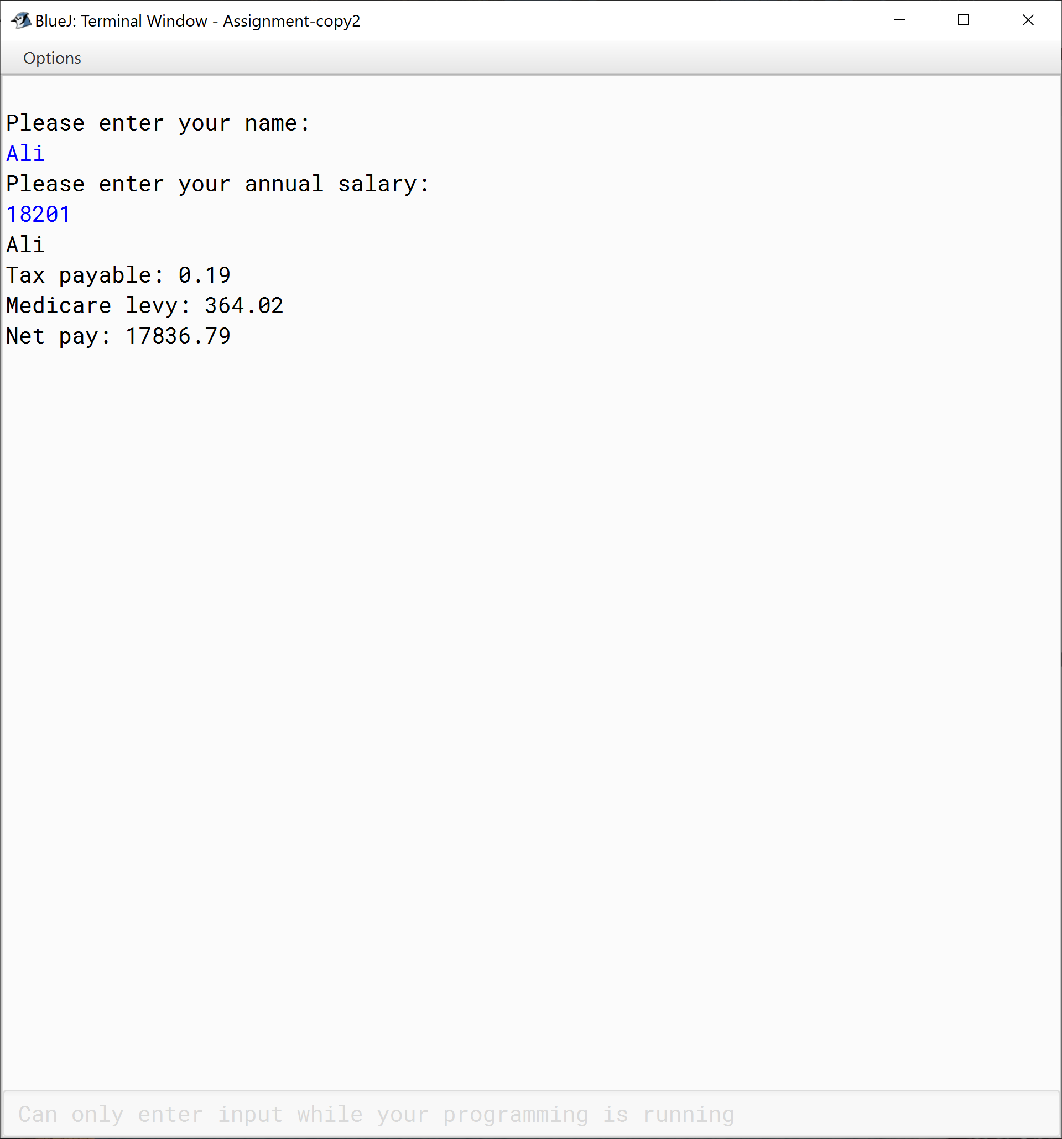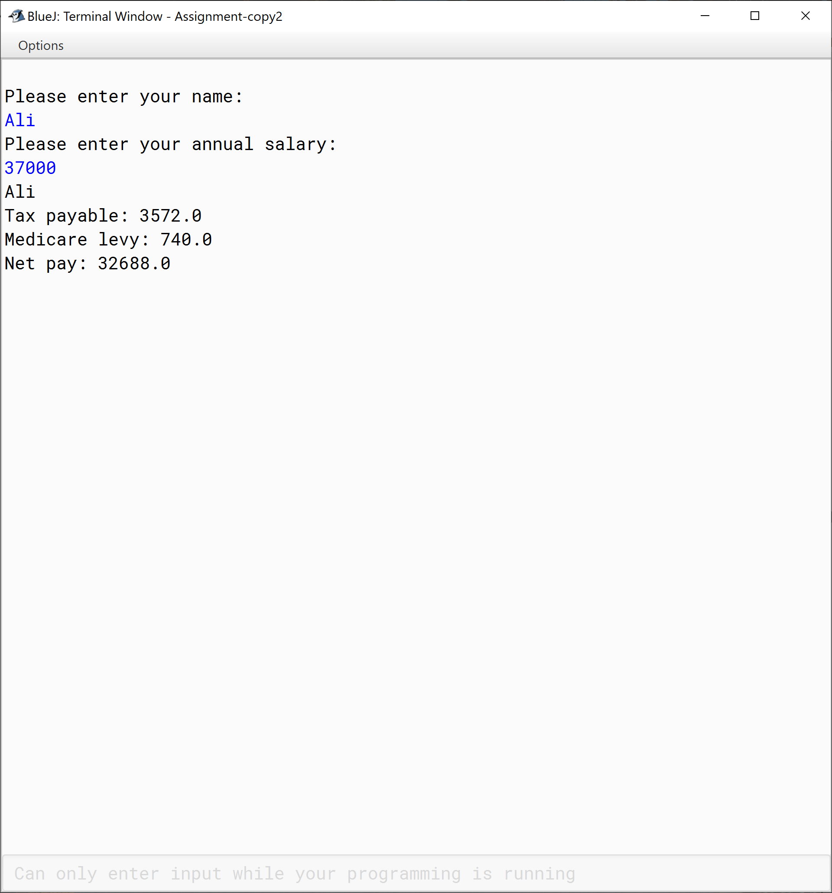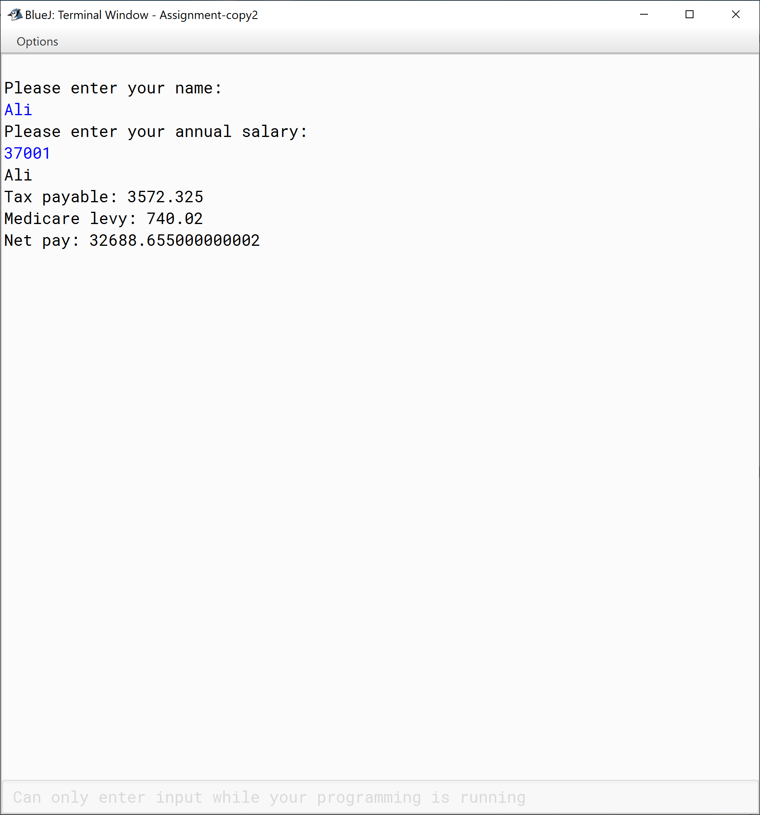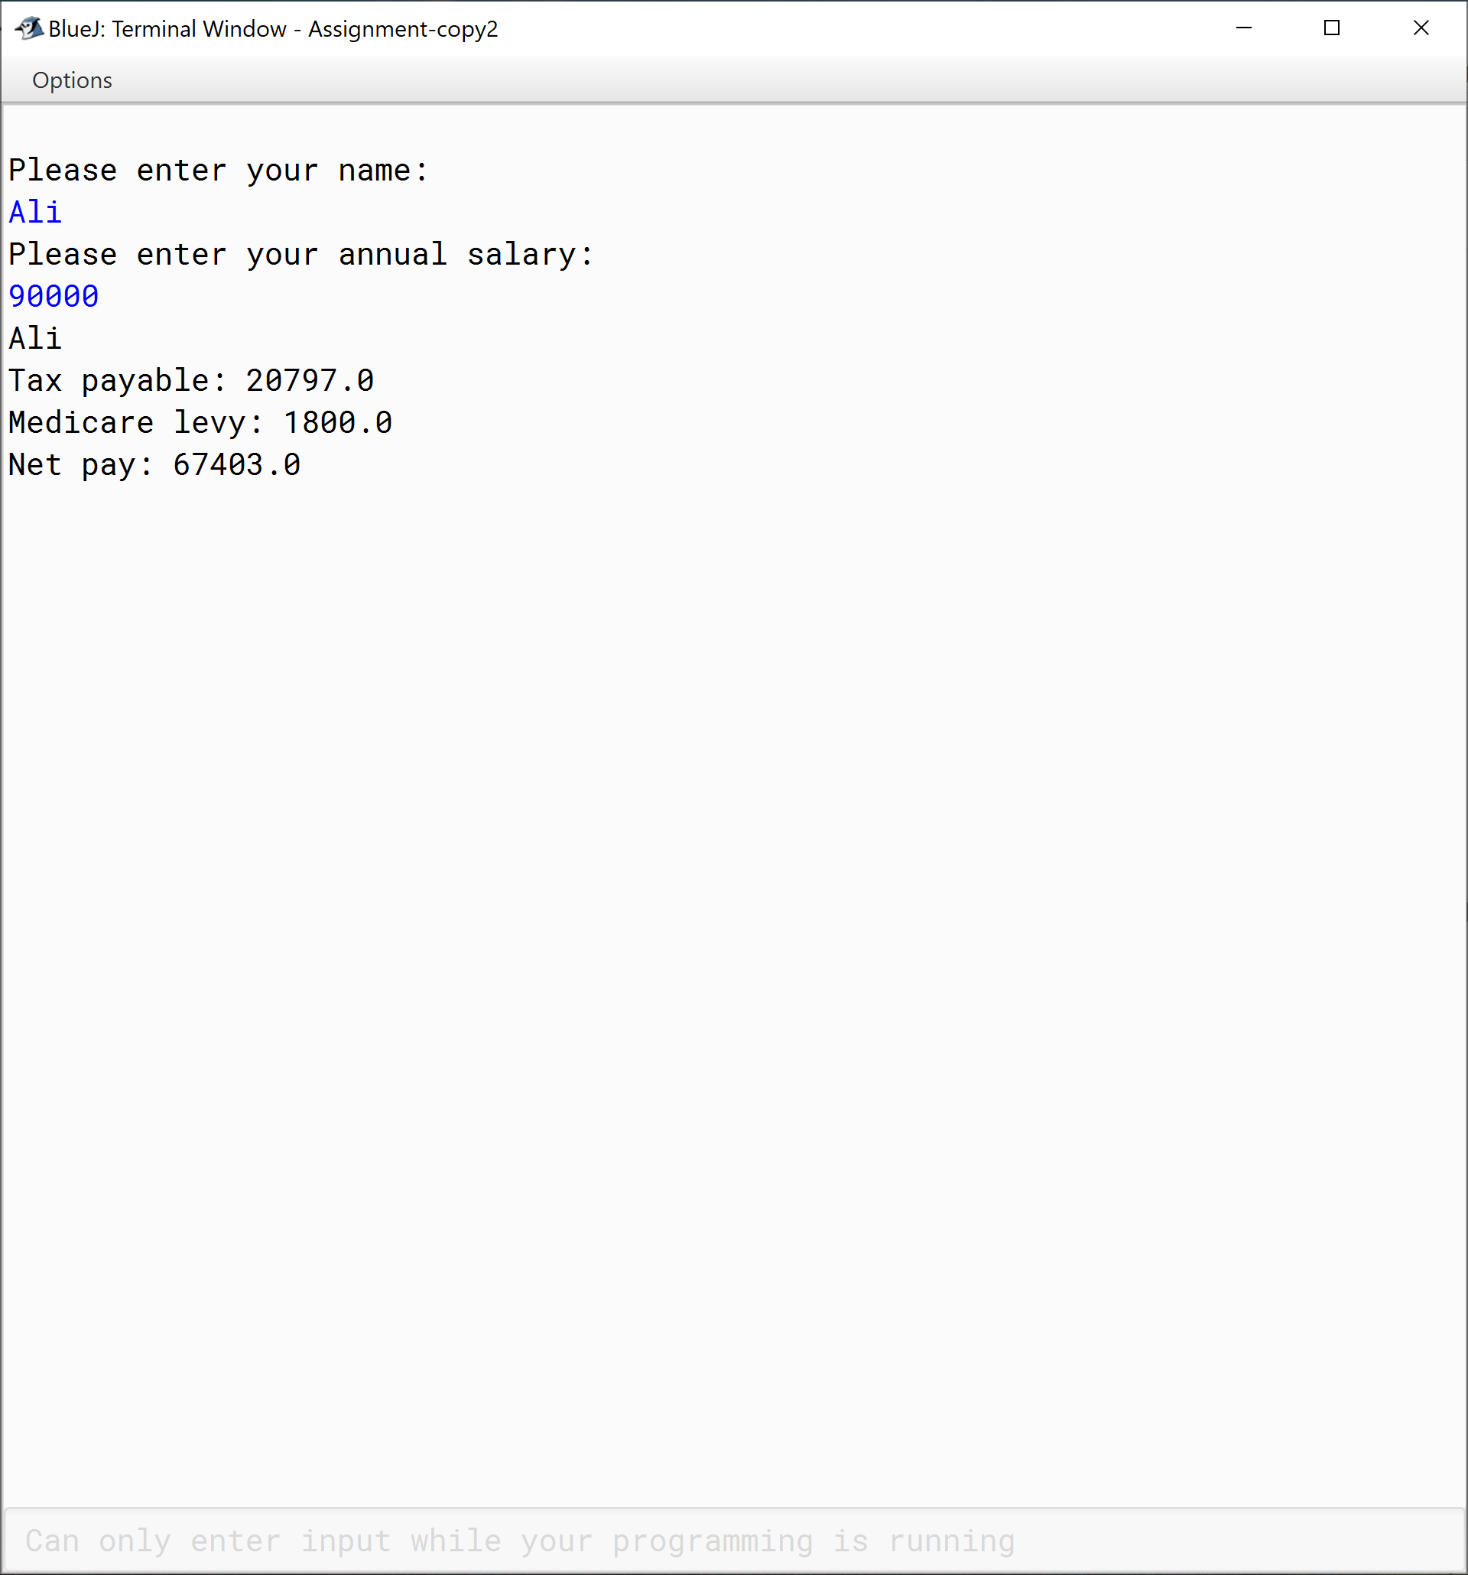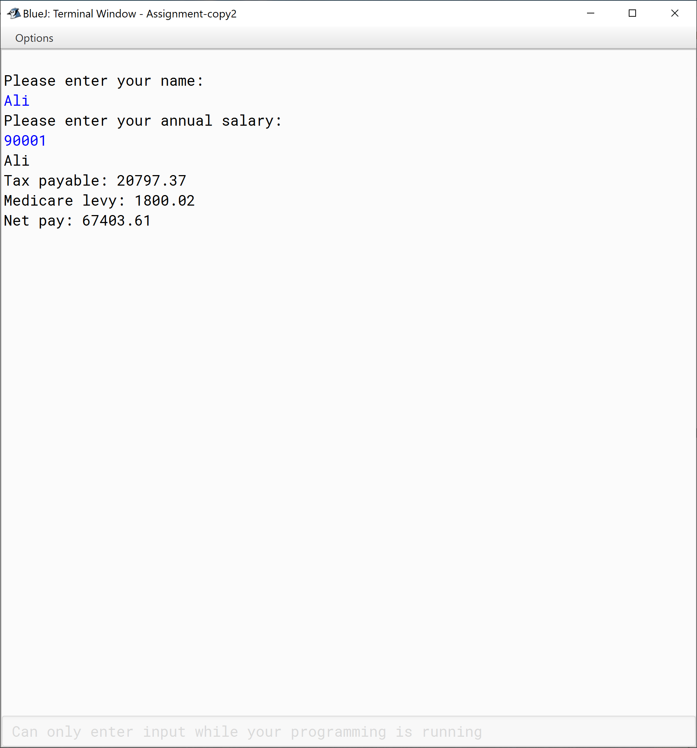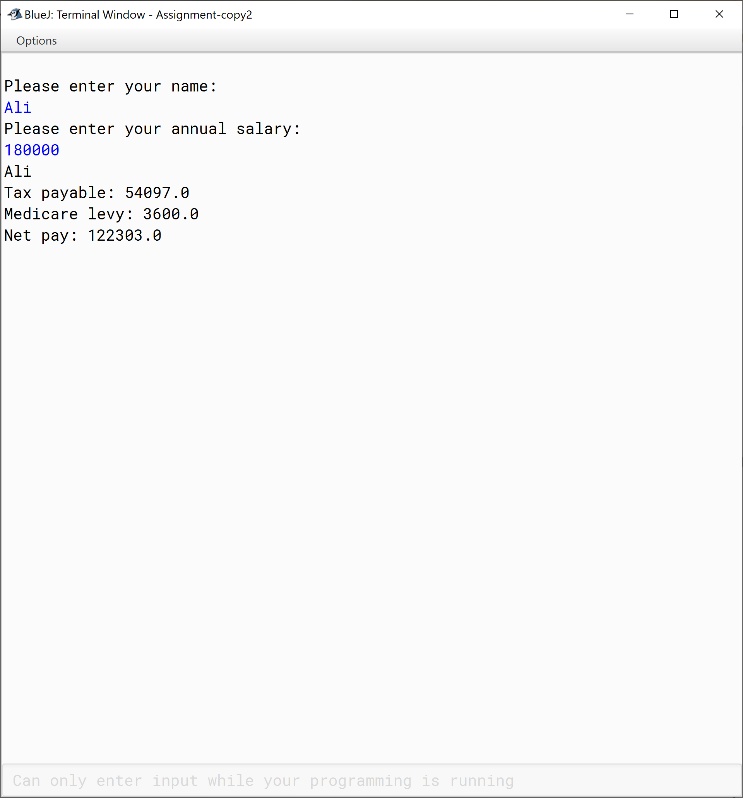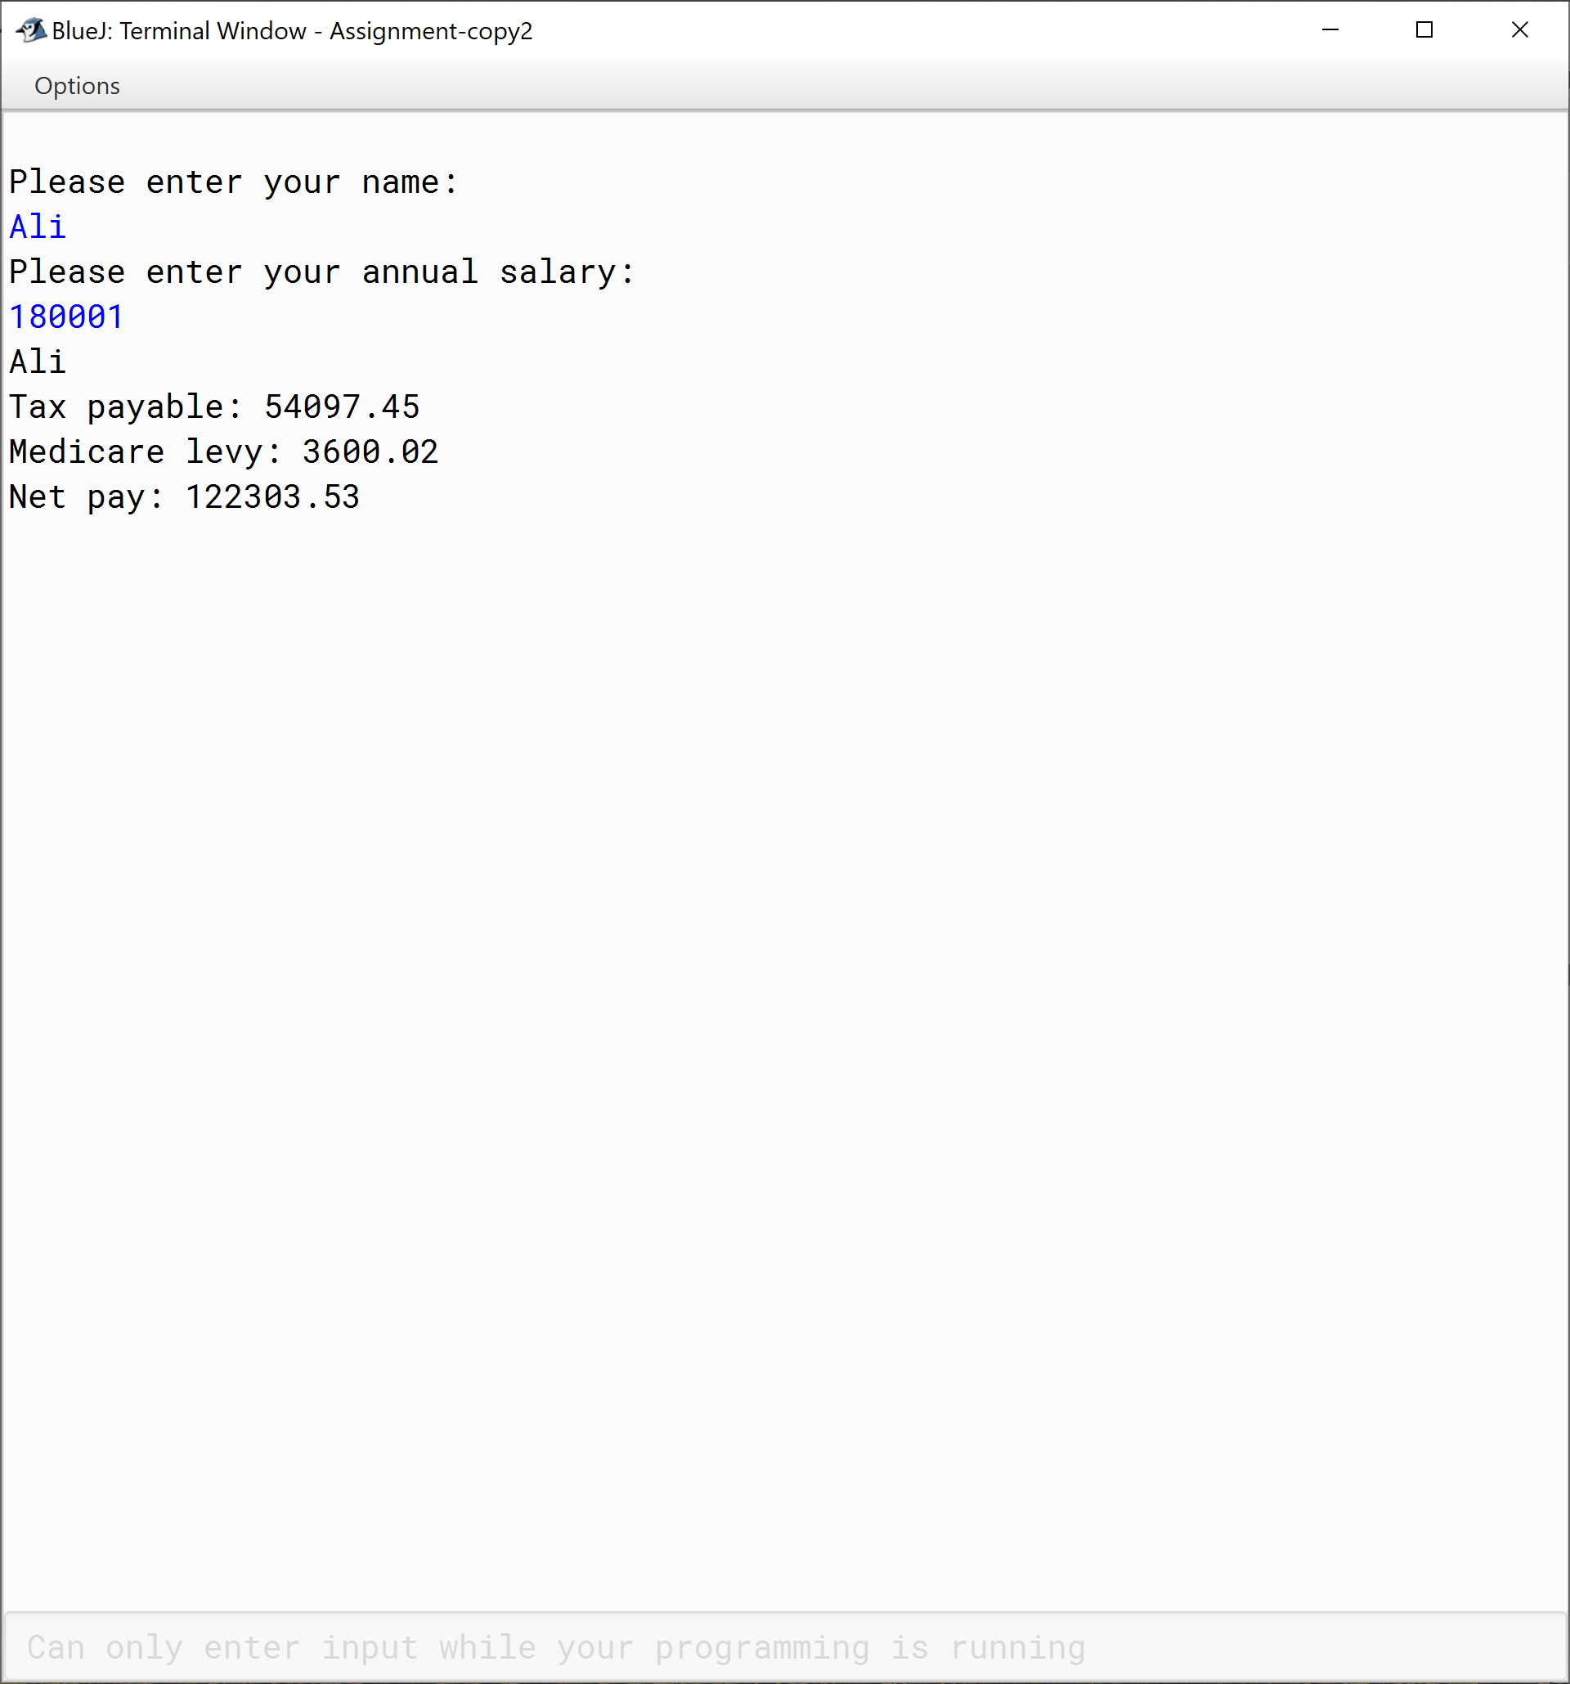

|  |  |  |  |  |  |  |  |  |  |  |
| --- | --- | --- | --- | --- | --- | --- | --- | --- | --- | --- |
| **Test Case ID** | | ARR_002 | **Test Case Description** | | Determines which quarter of the year the month is. | | | | | |
| **Created By** | | Ali AL-Salihi | **Reviewed By** | |  | | **Version** | | 2.0 | |
|  |  |  |  |  |  |  |  |  |  |  |
| **QA Tester’s Log** | | N/A | | | |  |  |  |  |  |
|  |  |  |  |  |  |  |  |  |  |  |
| **Tester's Name** | |  | **Date Tested** | | 21/08/2020 | | **Test Case (Pass/Fail/Not Executed)** | | Pass | |
|  |  |  |  |  |  |  |  |  |  |  |
| **S #** | **Prerequisites:** | | |  | **S #** | **Test Data** | | | | |
| 1 | The user must enter a month "Please input a month:" | | |  | 1 | 0 | | | | |
|  |  | | |  | 2 | 1 | | | | |
|  |  | | |  | 3 | 3 | | | | |
|  |  | | |  | 4 | 4 | | | | |
|  |  | | |  | 5 | 6 | | | | |
|  |  | | |  | 6 | 7 | | | | |
|  |  | | |  | 7 | 9 | | | | |
|  |  | | |  | 8 | 10 | | | | |
|  |  | | |  | 9 | 12 | | | | |
|  |  | | |  | 10 | 13 | | | | |
|  |  |  |  |  |  |  |  |  |  |  |
| **Test Scenario** | Month determition. | | | | | |  |  |  |  |
|  |  |  |  |  |  |  |  |  |  |  |
| **Step #** | **Step Details** | | **Expected Results** | | **Actual Results** | | | **Pass / Fail / Not executed / Suspended** | | |
|
| 1 | The user must be informed to enter the month. | | A message to inform the user "Please input a month:" | | As expected | | | Pass | | |
|  |  | |  | |  | | |  | | |
|  |  | |  | |  | | |  | | |
|  |  | |  | |  | | |  | | |

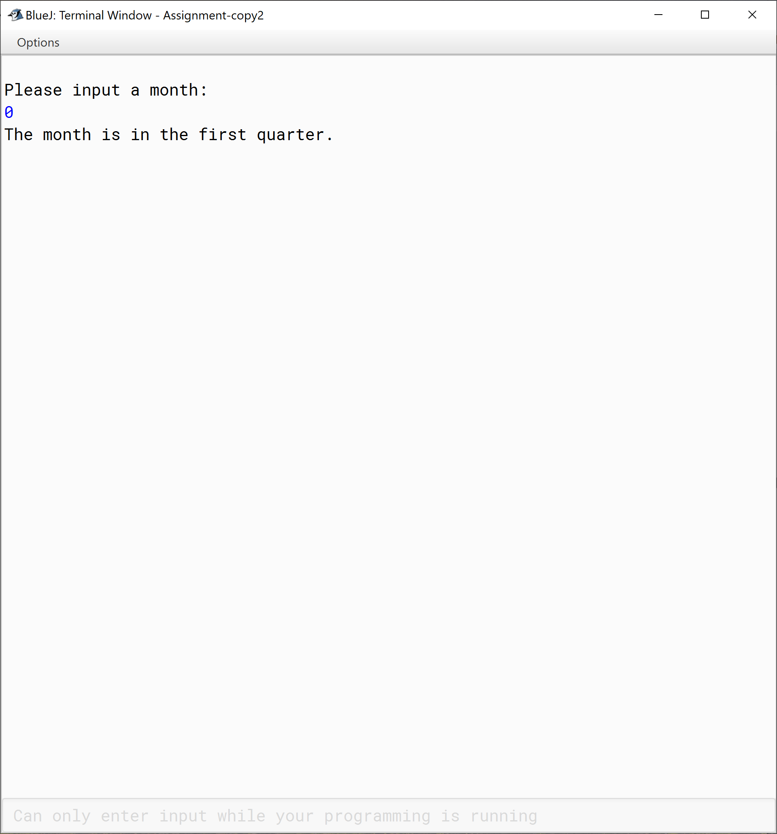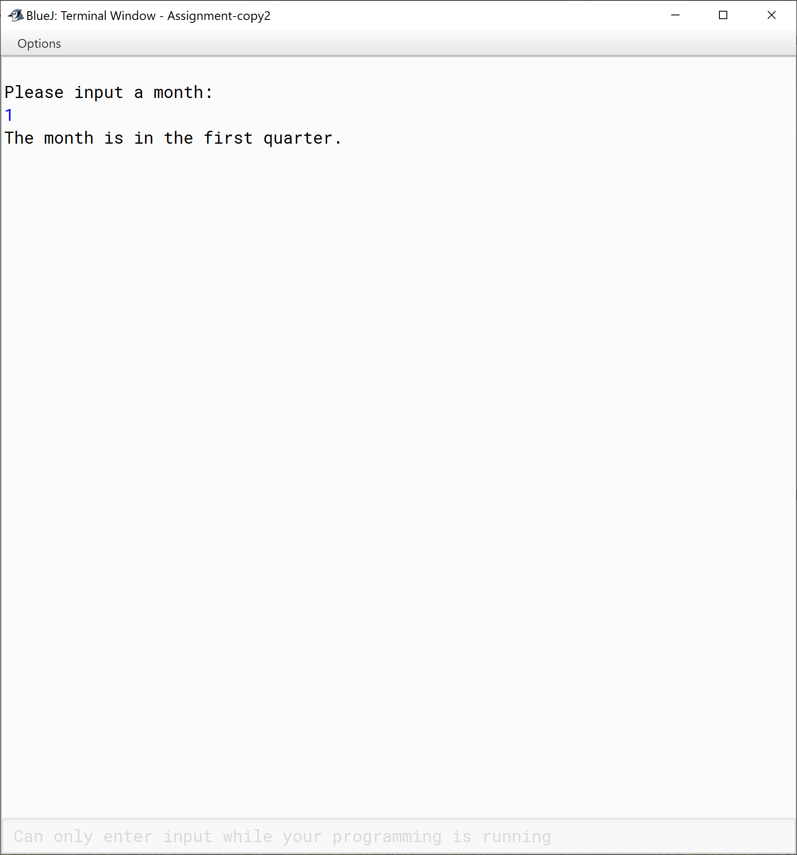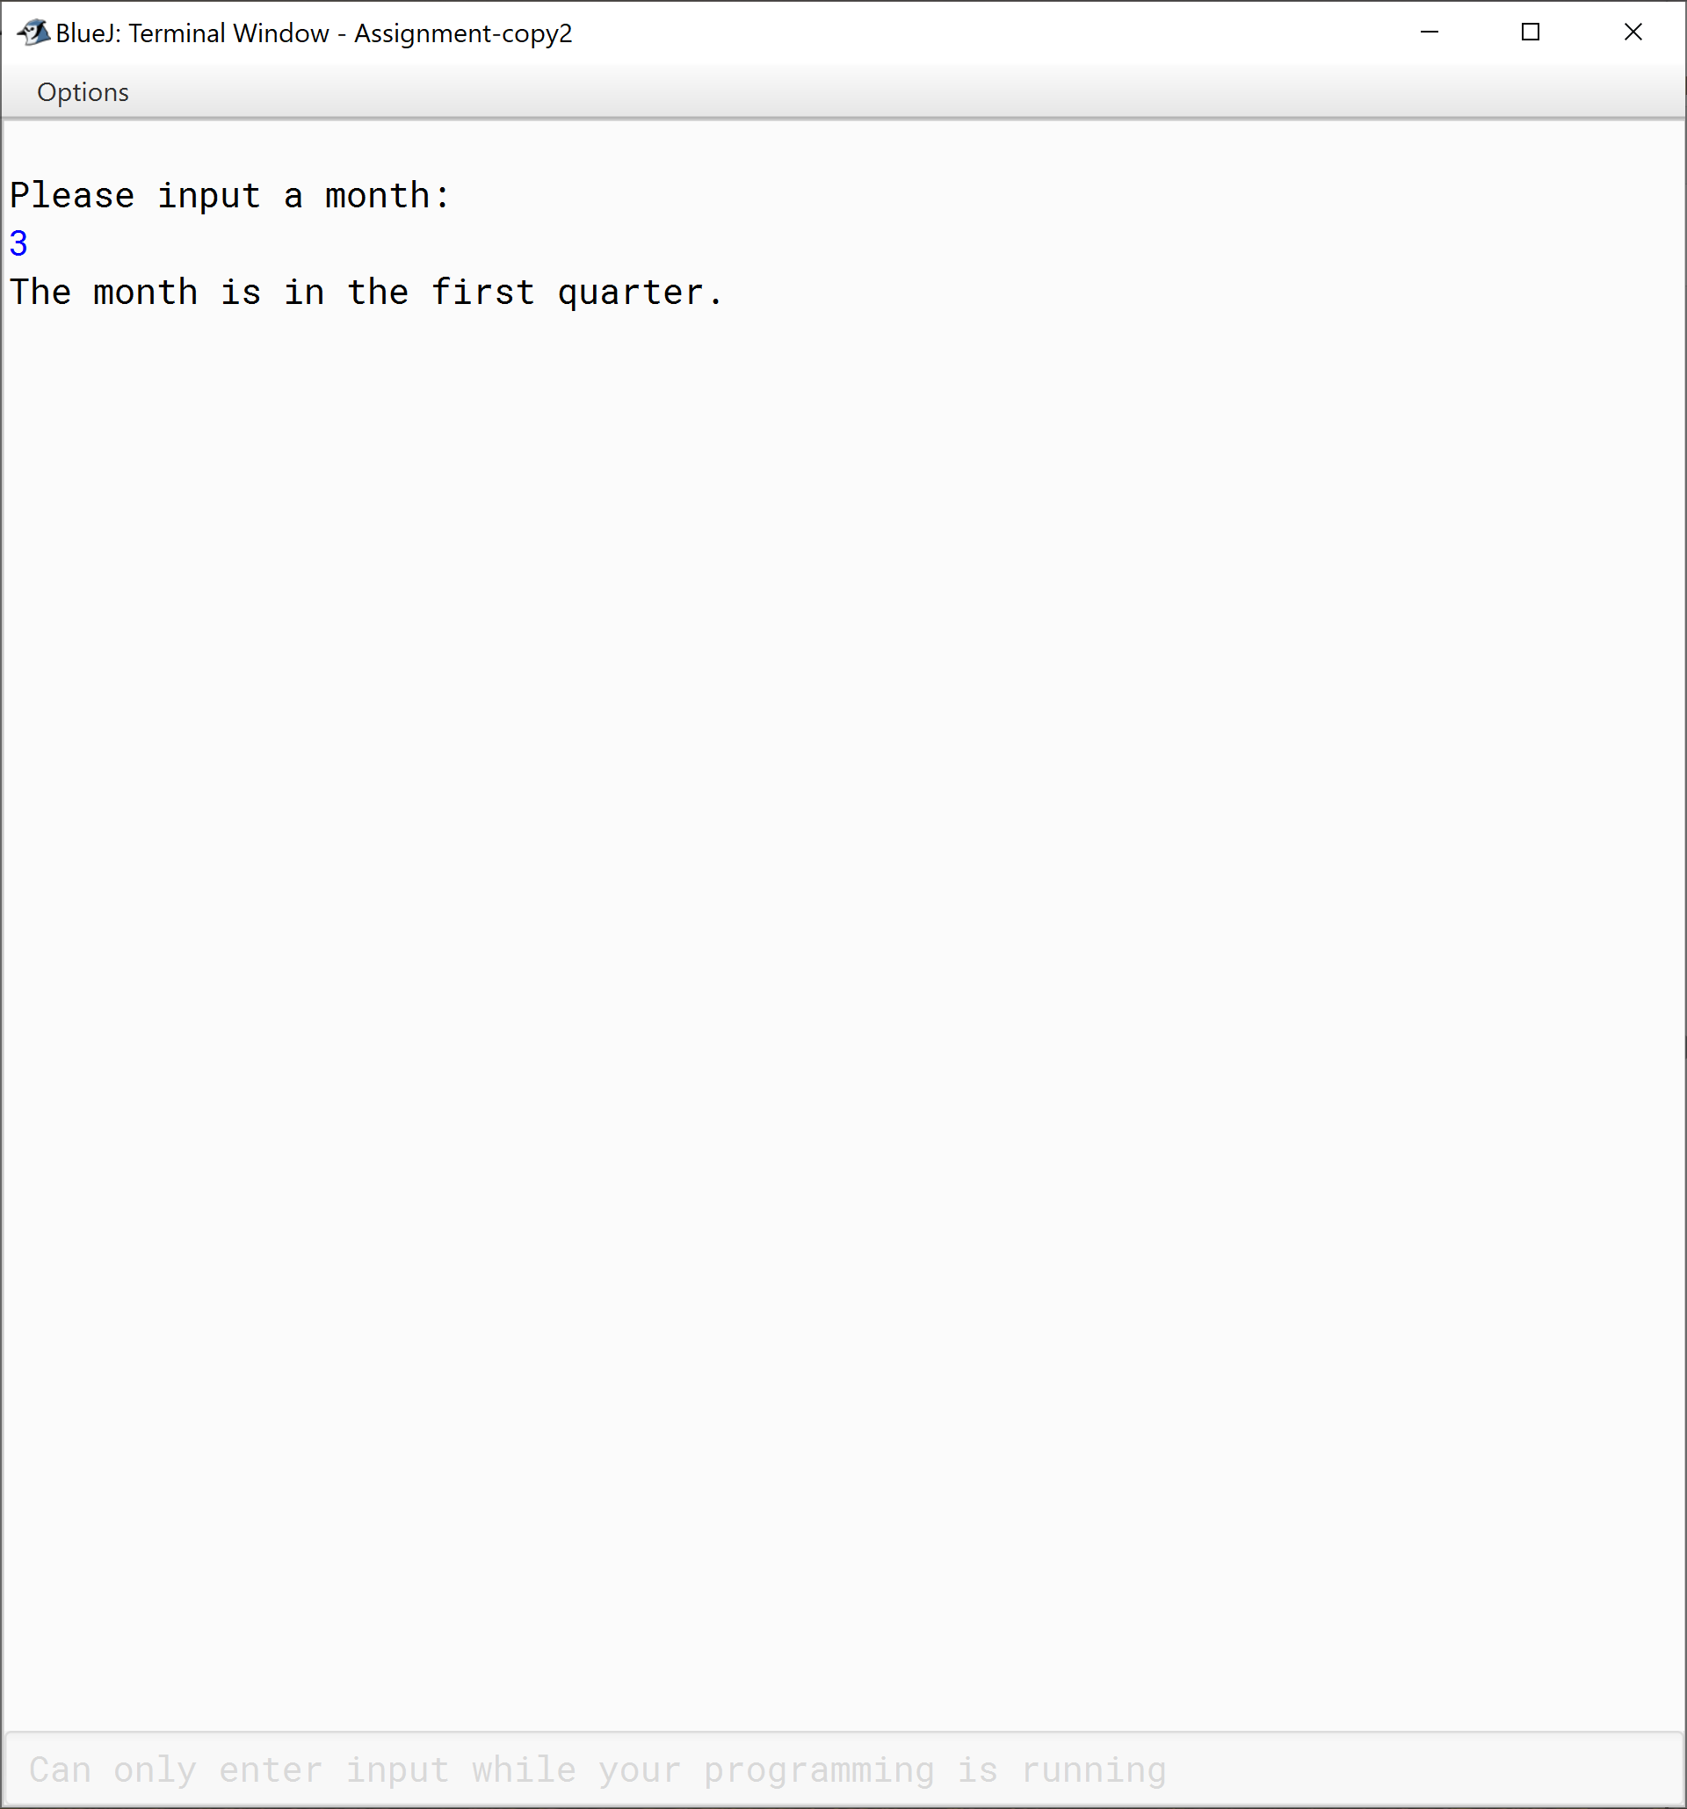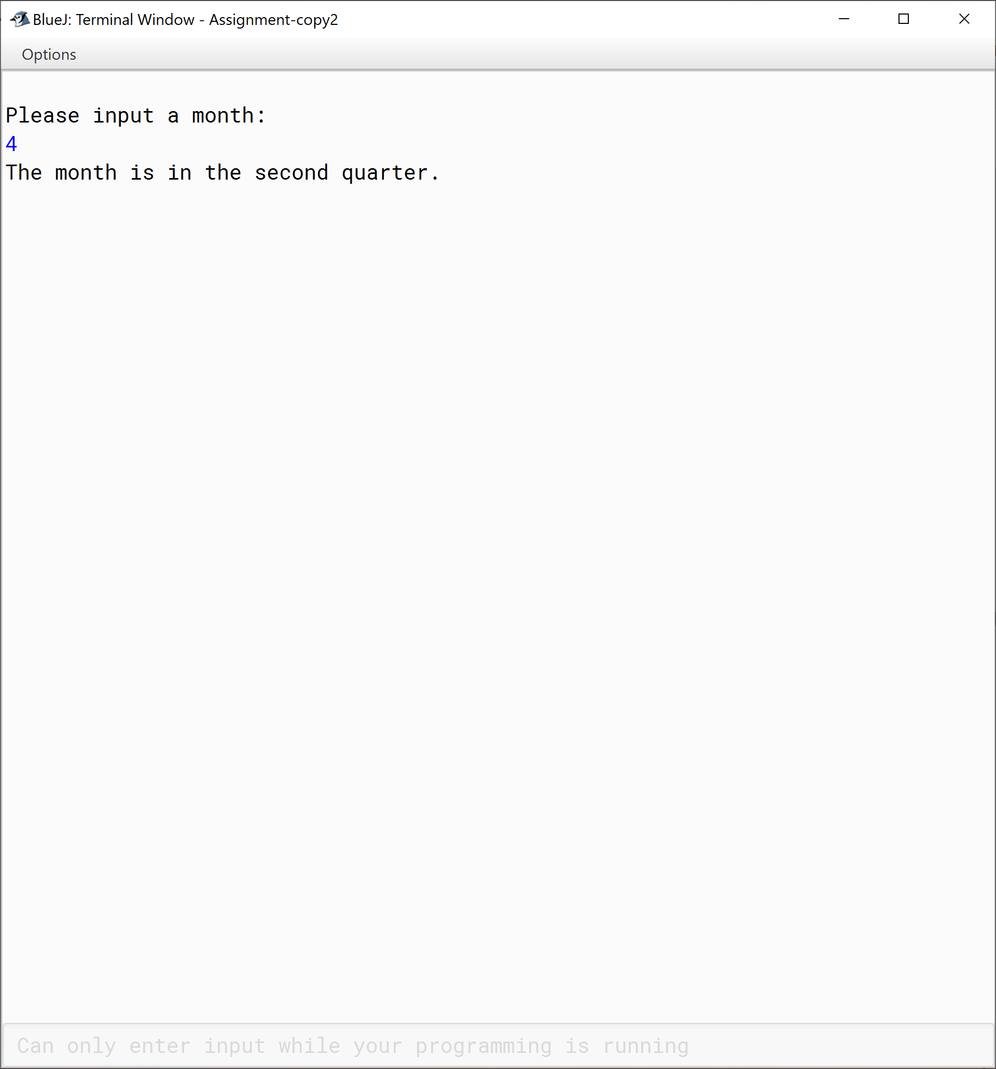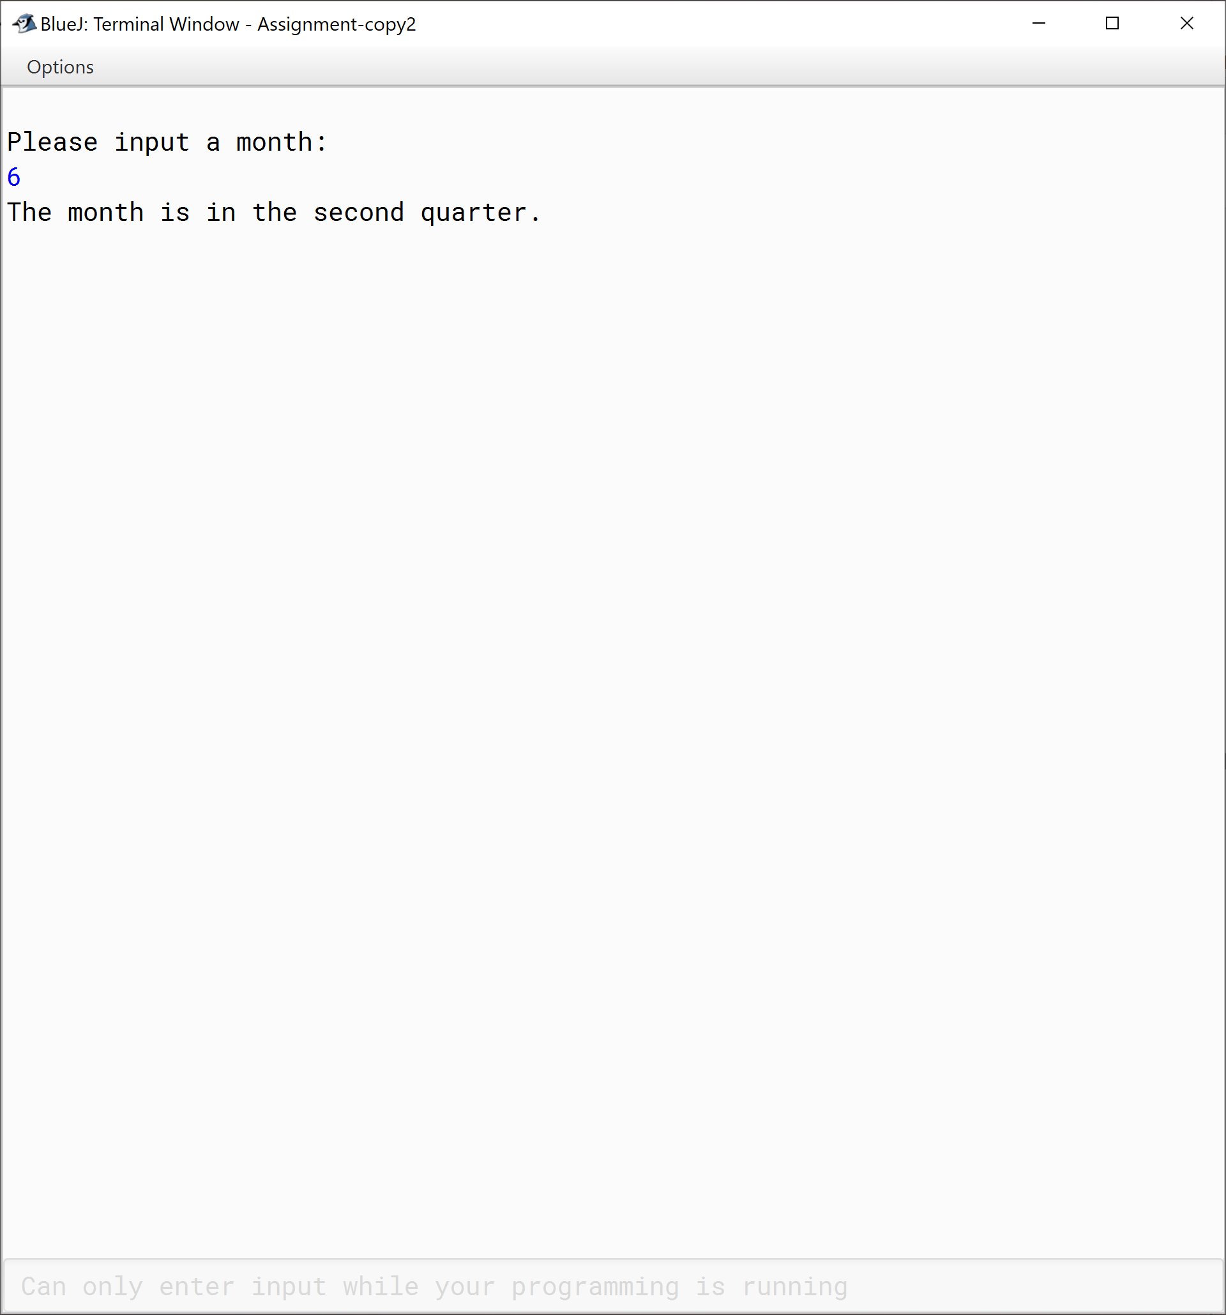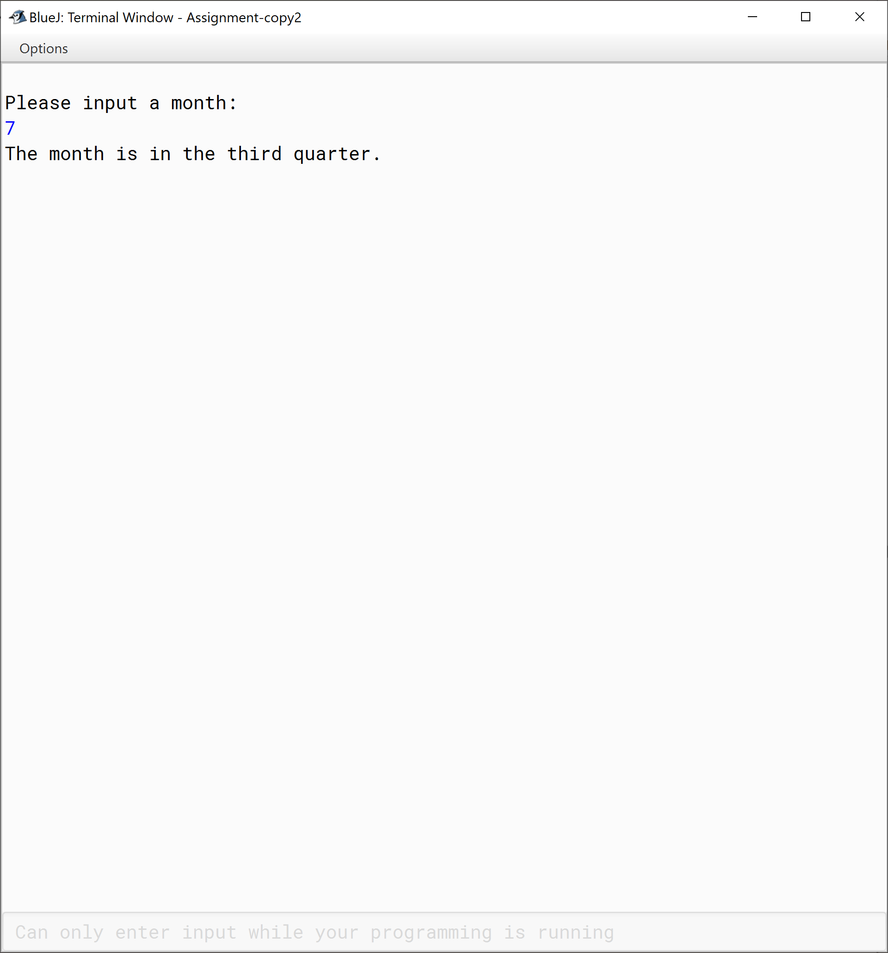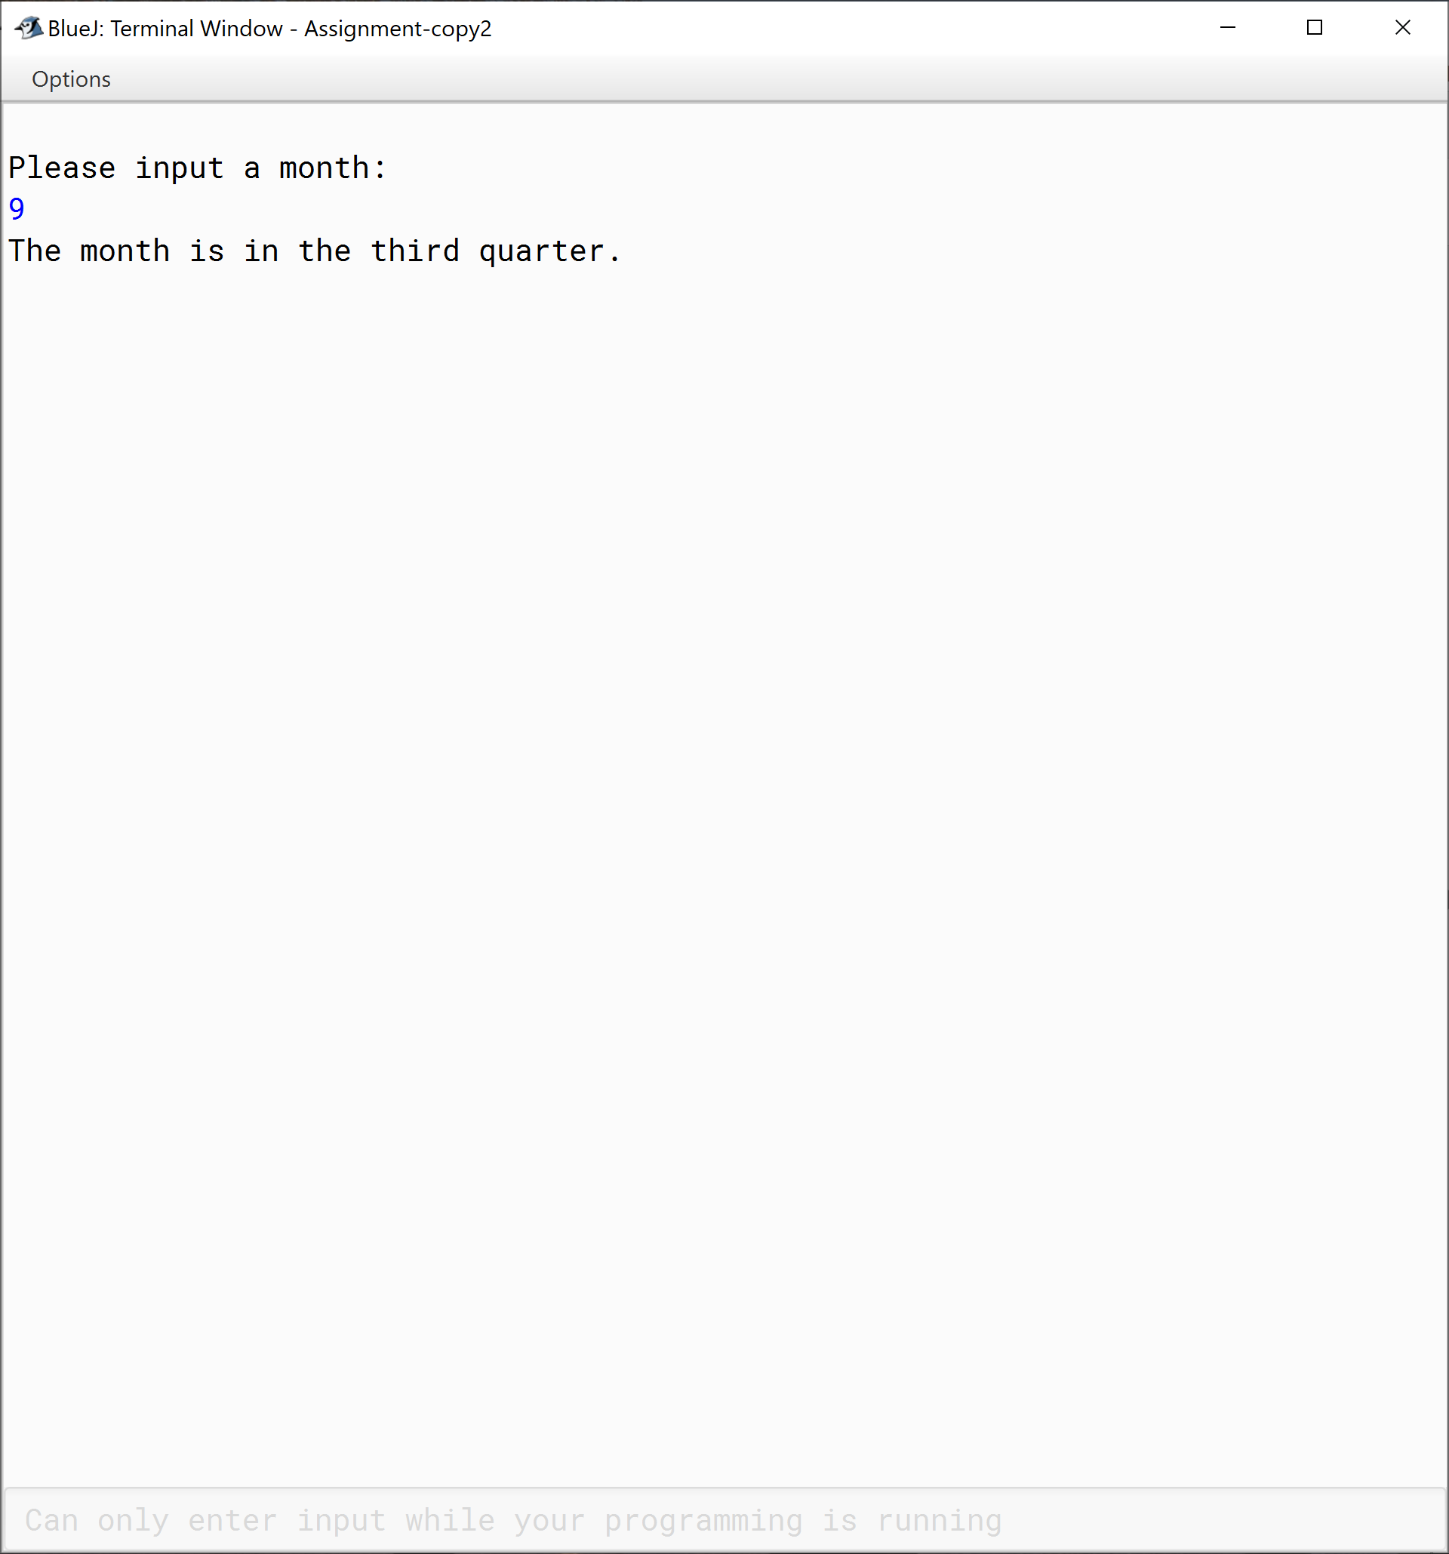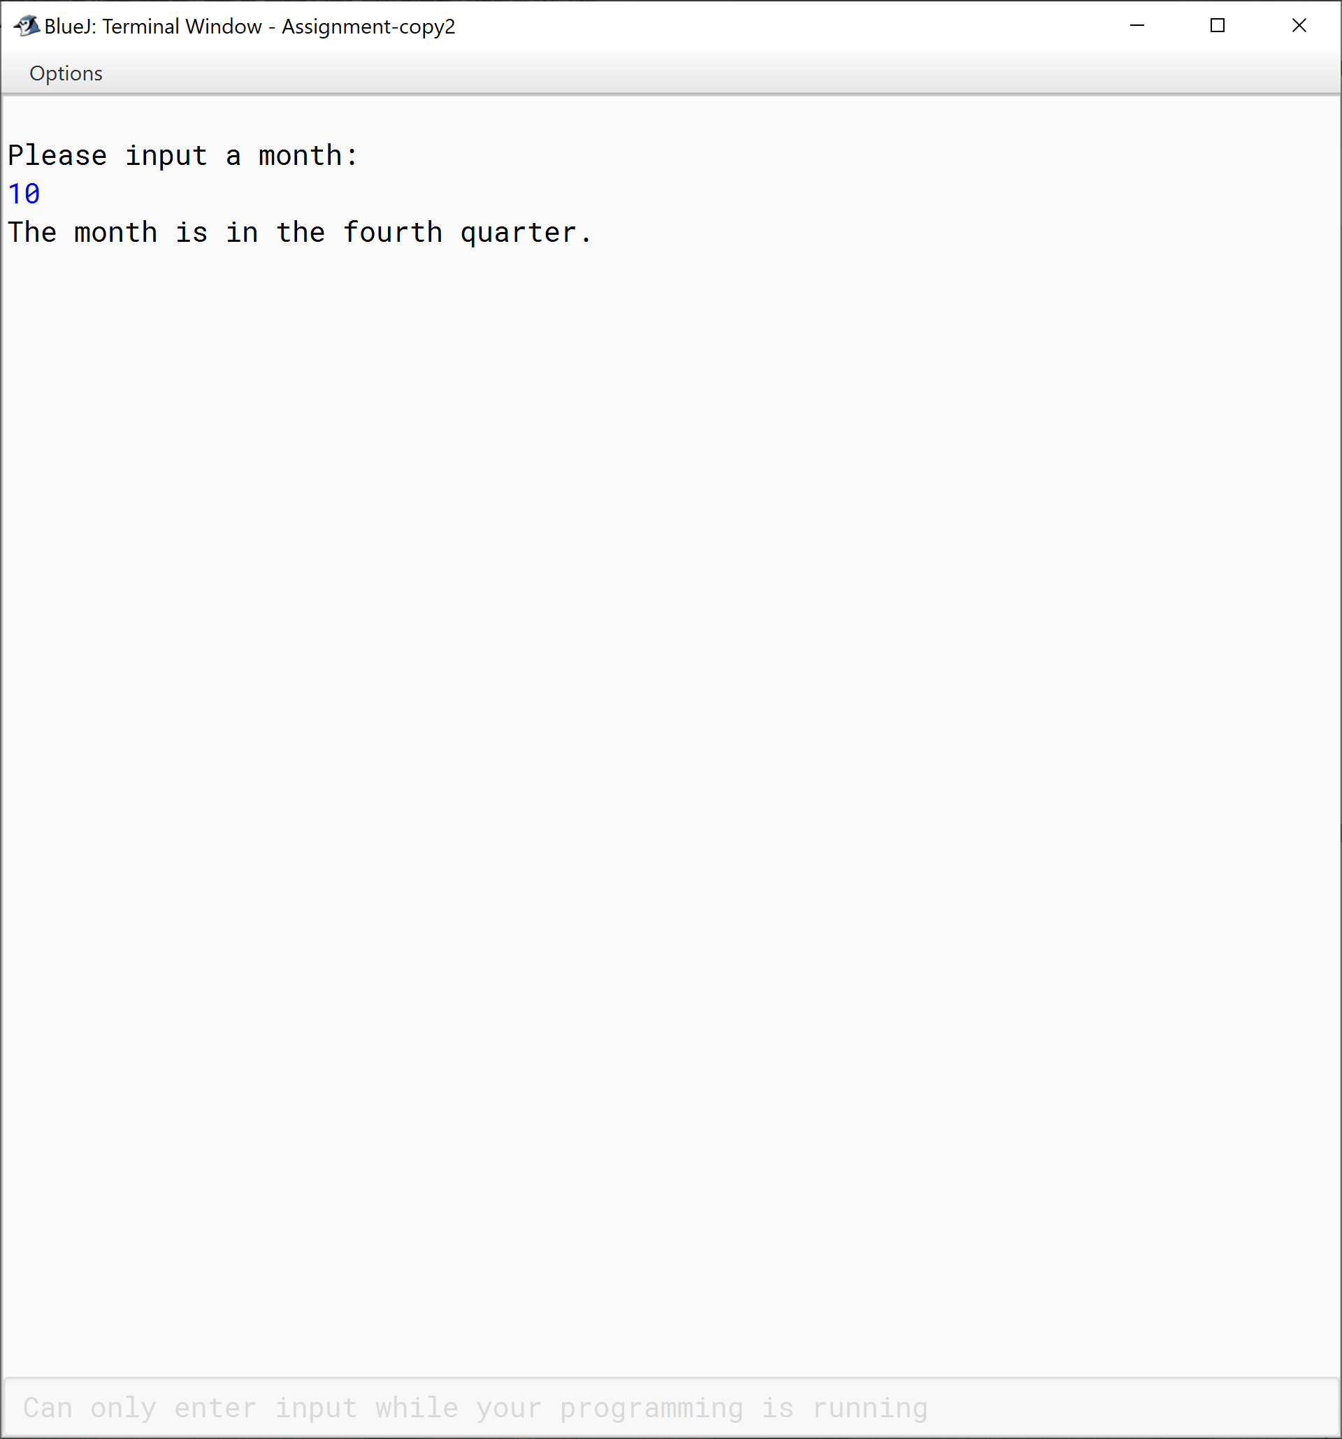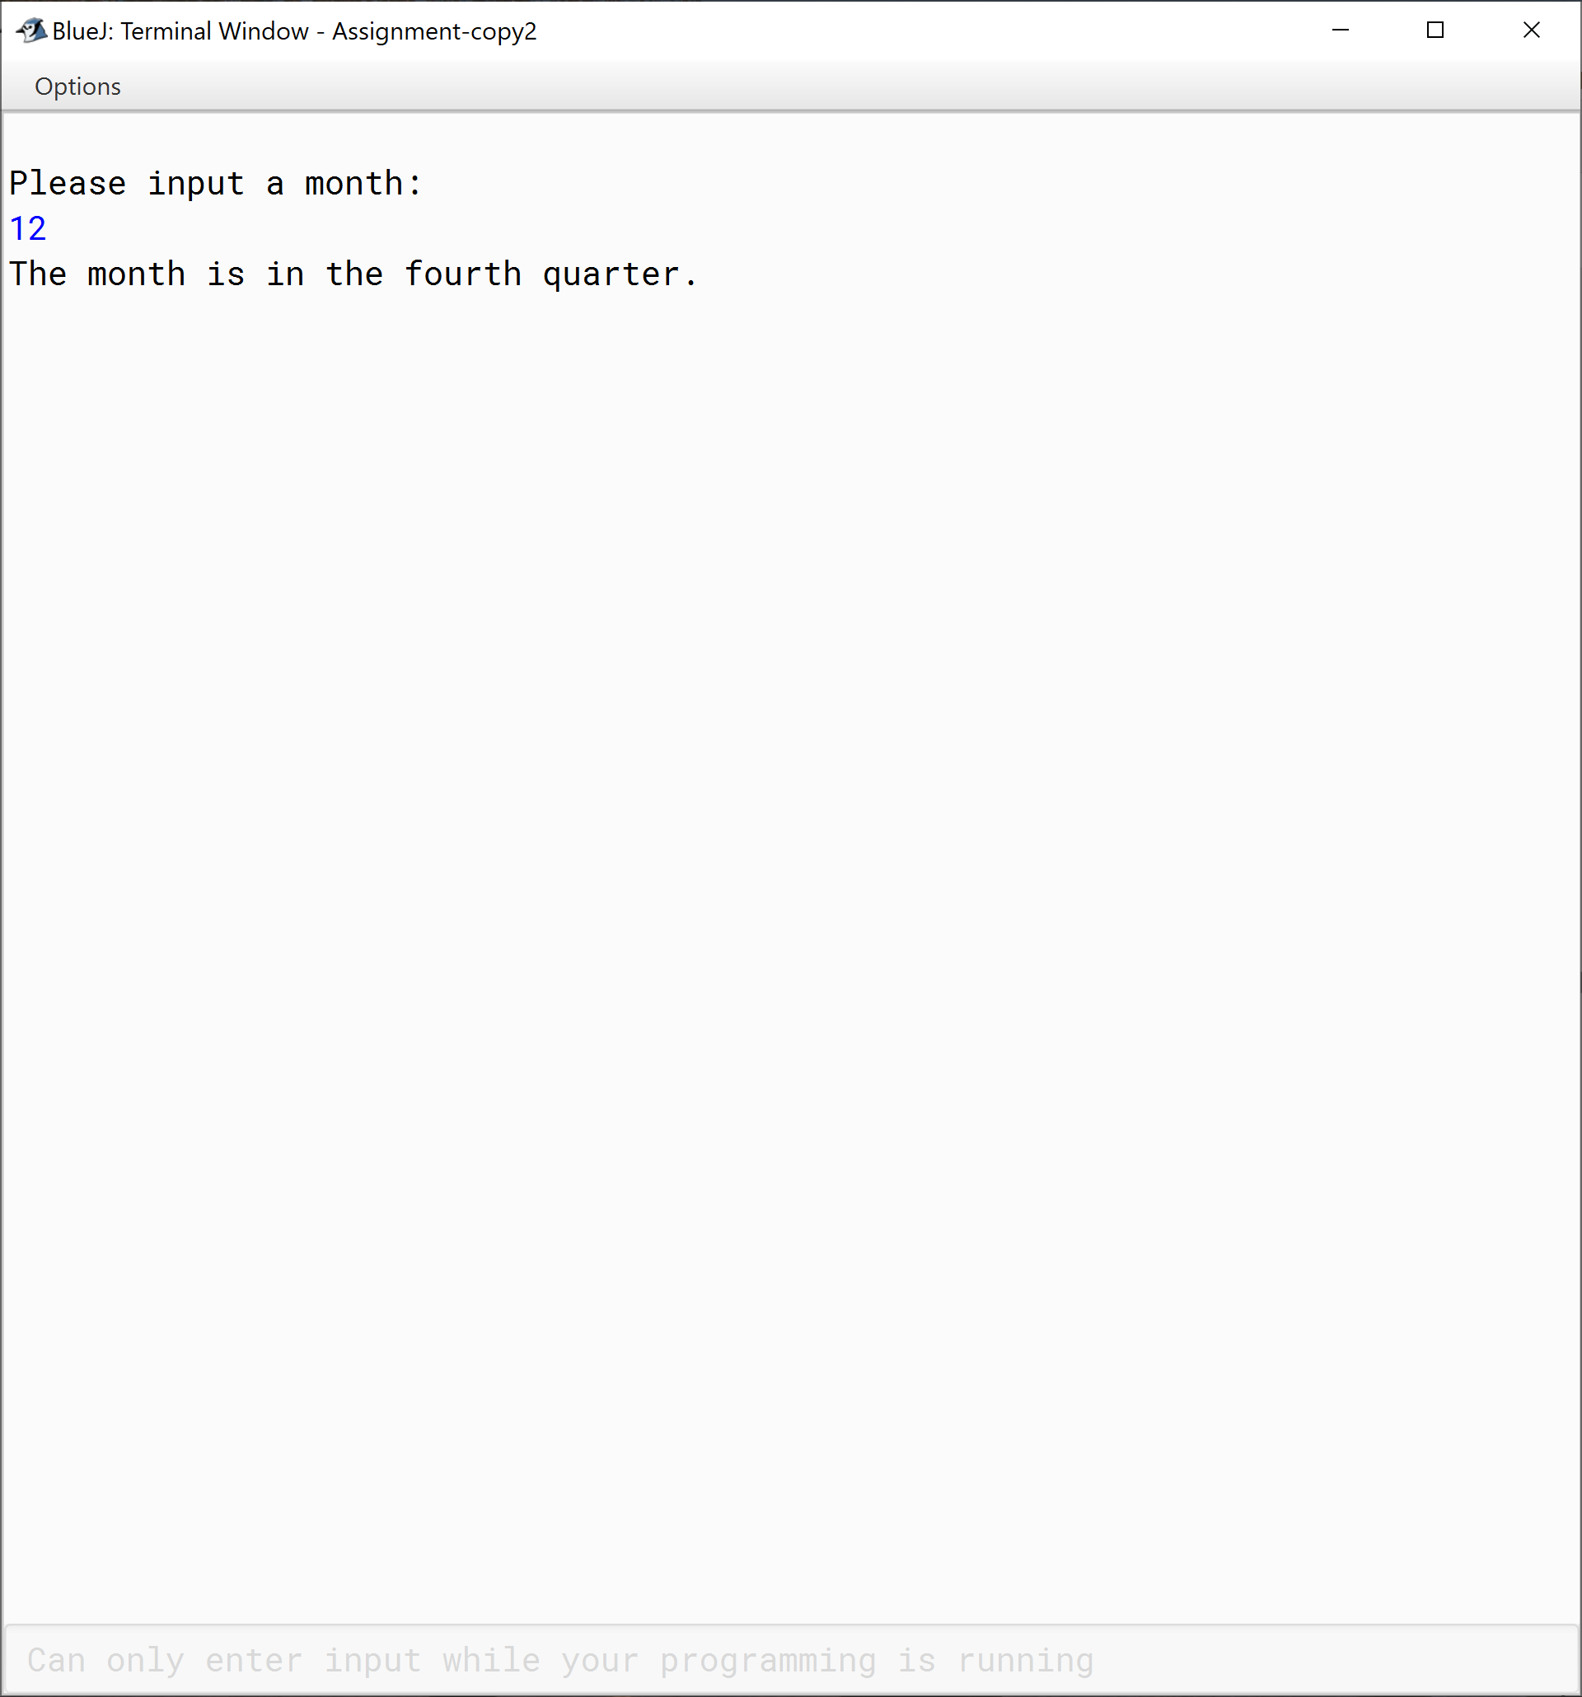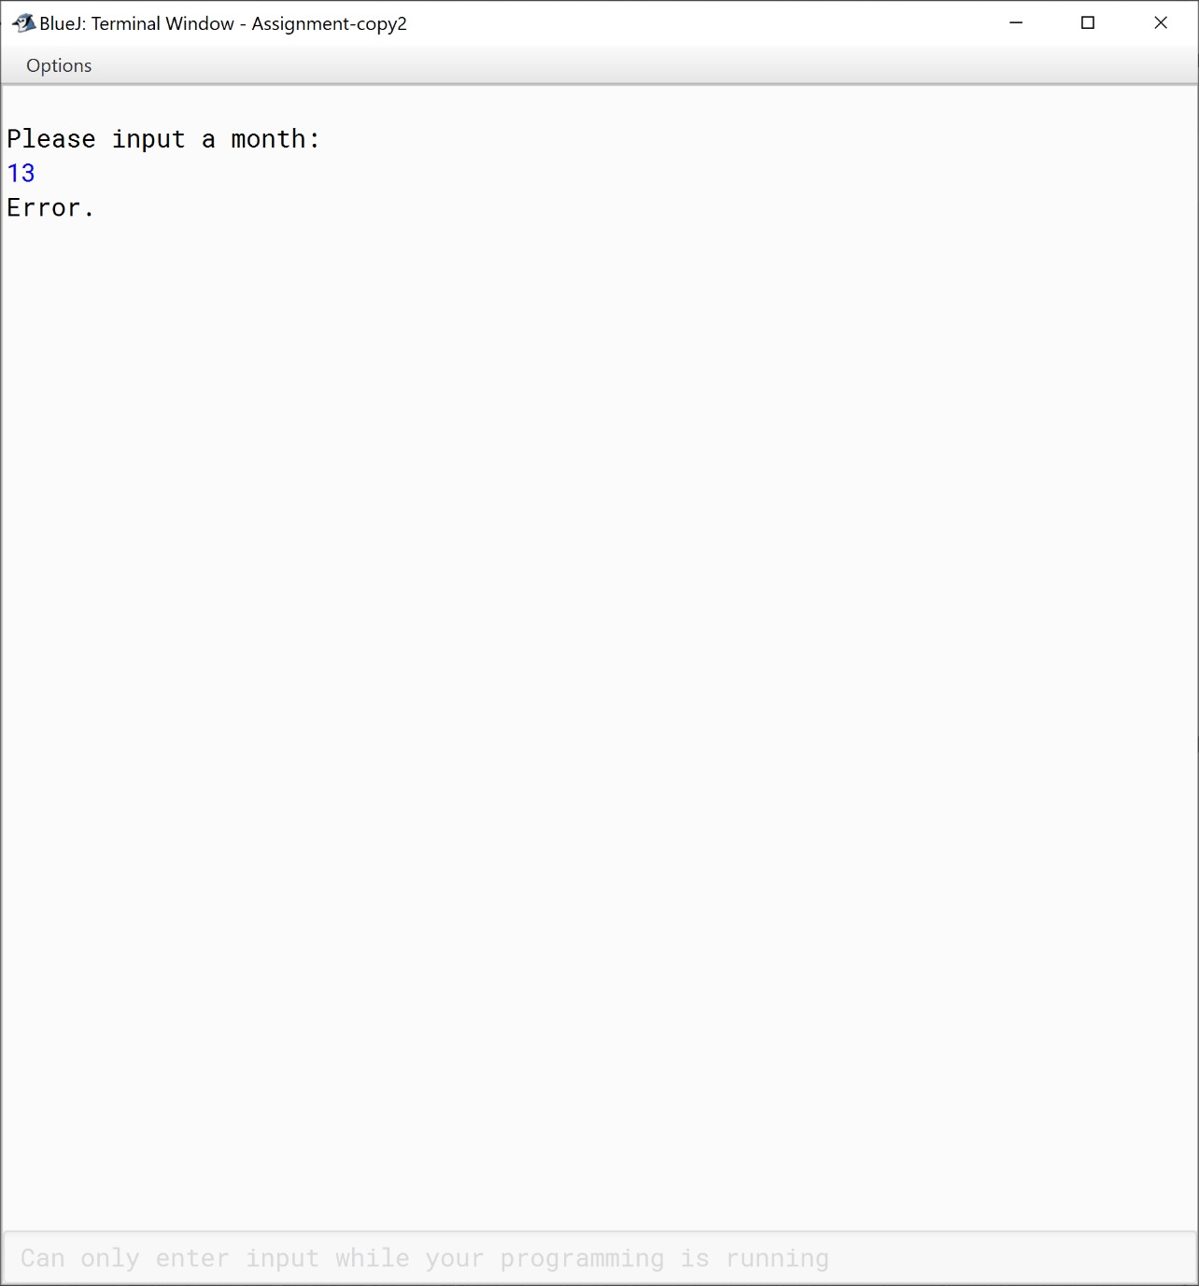

|  |  |  |  |  |  |  |  |  |  |  |
| --- | --- | --- | --- | --- | --- | --- | --- | --- | --- | --- |
| **Test Case ID** | | ARR_003 | **Test Case Description** | | Username reverse. | | | | | |
| **Created By** | | Ali AL-Salihi | **Reviewed By** | |  | | **Version** | | 3.0 | |
|  |  |  |  |  |  |  |  |  |  |  |
| **QA Tester’s Log** | | N/A | | | |  |  |  |  |  |
|  |  |  |  |  |  |  |  |  |  |  |
| **Tester's Name** | |  | **Date Tested** | | 2020/08/21 | | **Test Case (Pass/Fail/Not Executed)** | | Pass | |
|  |  |  |  |  |  |  |  |  |  |  |
| **S #** | **Prerequisites:** | | |  | **S #** | **Test Data** | | | | |
| 1 | The user must enter their first name "Please enter your first name:" | | |  | 1 | john smith | | | | |
| 2 | The user must enter their last name "Please enter your Last name:" | | |  | 2 | mohammed emad | | | | |
|  |  | | |  | 3 | ali al-salihi | | | | |
|  |  |  |  |  |  |  |  |  |  |  |
| **Test Scenario** | Name reversing step. | | | | | |  |  |  |  |
|  |  |  |  |  |  |  |  |  |  |  |
| **Step #** | **Step Details** | | **Expected Results** | | **Actual Results** | | | **Pass / Fail / Not executed / Suspended** | | |
|
| 1 | The user must be asked to input their first name | | A message to inform the user " Please enter your first name:" | | As expected | | | Pass | | |
| 2 | The user must be asked to input their last name | | A message to inform the user " Please enter your last name:" | | As expected | | | pass | | |

|  |  |  |  |  |  |
| --- | --- | --- | --- | --- | --- |
|  |  |  |  |  |  |
|  |  |  |  |  |
|  |  | | | | | |  |  |  |  |  |  |  |  |  |
|  |  | | | | | |  |  |  |  |  |  |  |  |  |
| **Test Scenario** | Hotel Calculator. | | | | | | | | | | |  |  |  |  |
|  |  | | | | | |  |  |  |  |  |  |  |  |  |
| **Step #** | **Step Details** | | | | | | | **Expected Results** | | **Actual Results** | | | **Pass / Fail / Not executed / Suspended** | | |
|
| 1 | The user must be asked to input their title such as Mr,Ms etc | | | | | | | A message to inform the user " Please enter your title::" | | As expected | | | Pass | | |
| 2 | The user must be asked to input their name | | | | | | | A message to inform the user " Please enter your name:" | | As expected | | | pass | | |
| 3 | The user must be asked to input their days spent in the hotel | | | | | | | A message to inform the user " Please enter the number of days spent in the hotel:" | | As expected | | | pass | | |
| 4 | The user must be asked to input their amount the restaurant charges | | | | | | | A message to inform the user " Please enter the amount of restaurant charges:" | | As expected | | | pass | | |
| 5 | The user must be asked to input their amount the creation charges | | | | | | | A message to inform the user " Please enter the amount of recreational charges:" | | As expected | | | pass | | |
| 6 | The user must be asked to input their amount the creation charges | | | | | | | A message to inform the user " Please enter the amount of recreational charges:" | | As expected | | | pass | | |
| 7 | The user must be asked to input their amount spent on the gym | | | | | | | A message to inform the user " Please enter the amount of gym fees:” | | As expected | | | Pass | | |
| 8 | The user must be asked to input their amount spent for the services | | | | | | | A message to inform the user " Please enter your the amount for service charges:” | | As expected | | | Pass | | |

|  |  |  |  |  |  |  |  |  |  |  |
| --- | --- | --- | --- | --- | --- | --- | --- | --- | --- | --- |
| **Test Case ID** | | ARR_004 | **Test Case Description** | | Calculates hotel tax, stay..etc. | | | | | |
| **Created By** | | Ali AL-Salihi | **Reviewed By** | |  | | **Version** | | 4.0 | |
|  |  |  |  |  |  |  |  |  |  |  |
| **QA Tester’s Log** | | N/A | | | |  |  |  |  |  |
|  |  |  |  |  |  |  |  |  |  |  |
| **Tester's Name** | |  | **Date Tested** | | 2020/08/21 | | **Test Case (Pass/Fail/Not Executed)** | | Pass | |
| **S #** | **Prerequisites:** | | |  | **S #** | **Test Data** | | | | |
| 1 | The user must enter their first name "Please enter your title:" | | |  | 1 | Mr | | | | |
| 2 | The user must enter their last name "Please enter your name:" | | |  | 2 | Ameen | | | | |
|  |  |  |  |

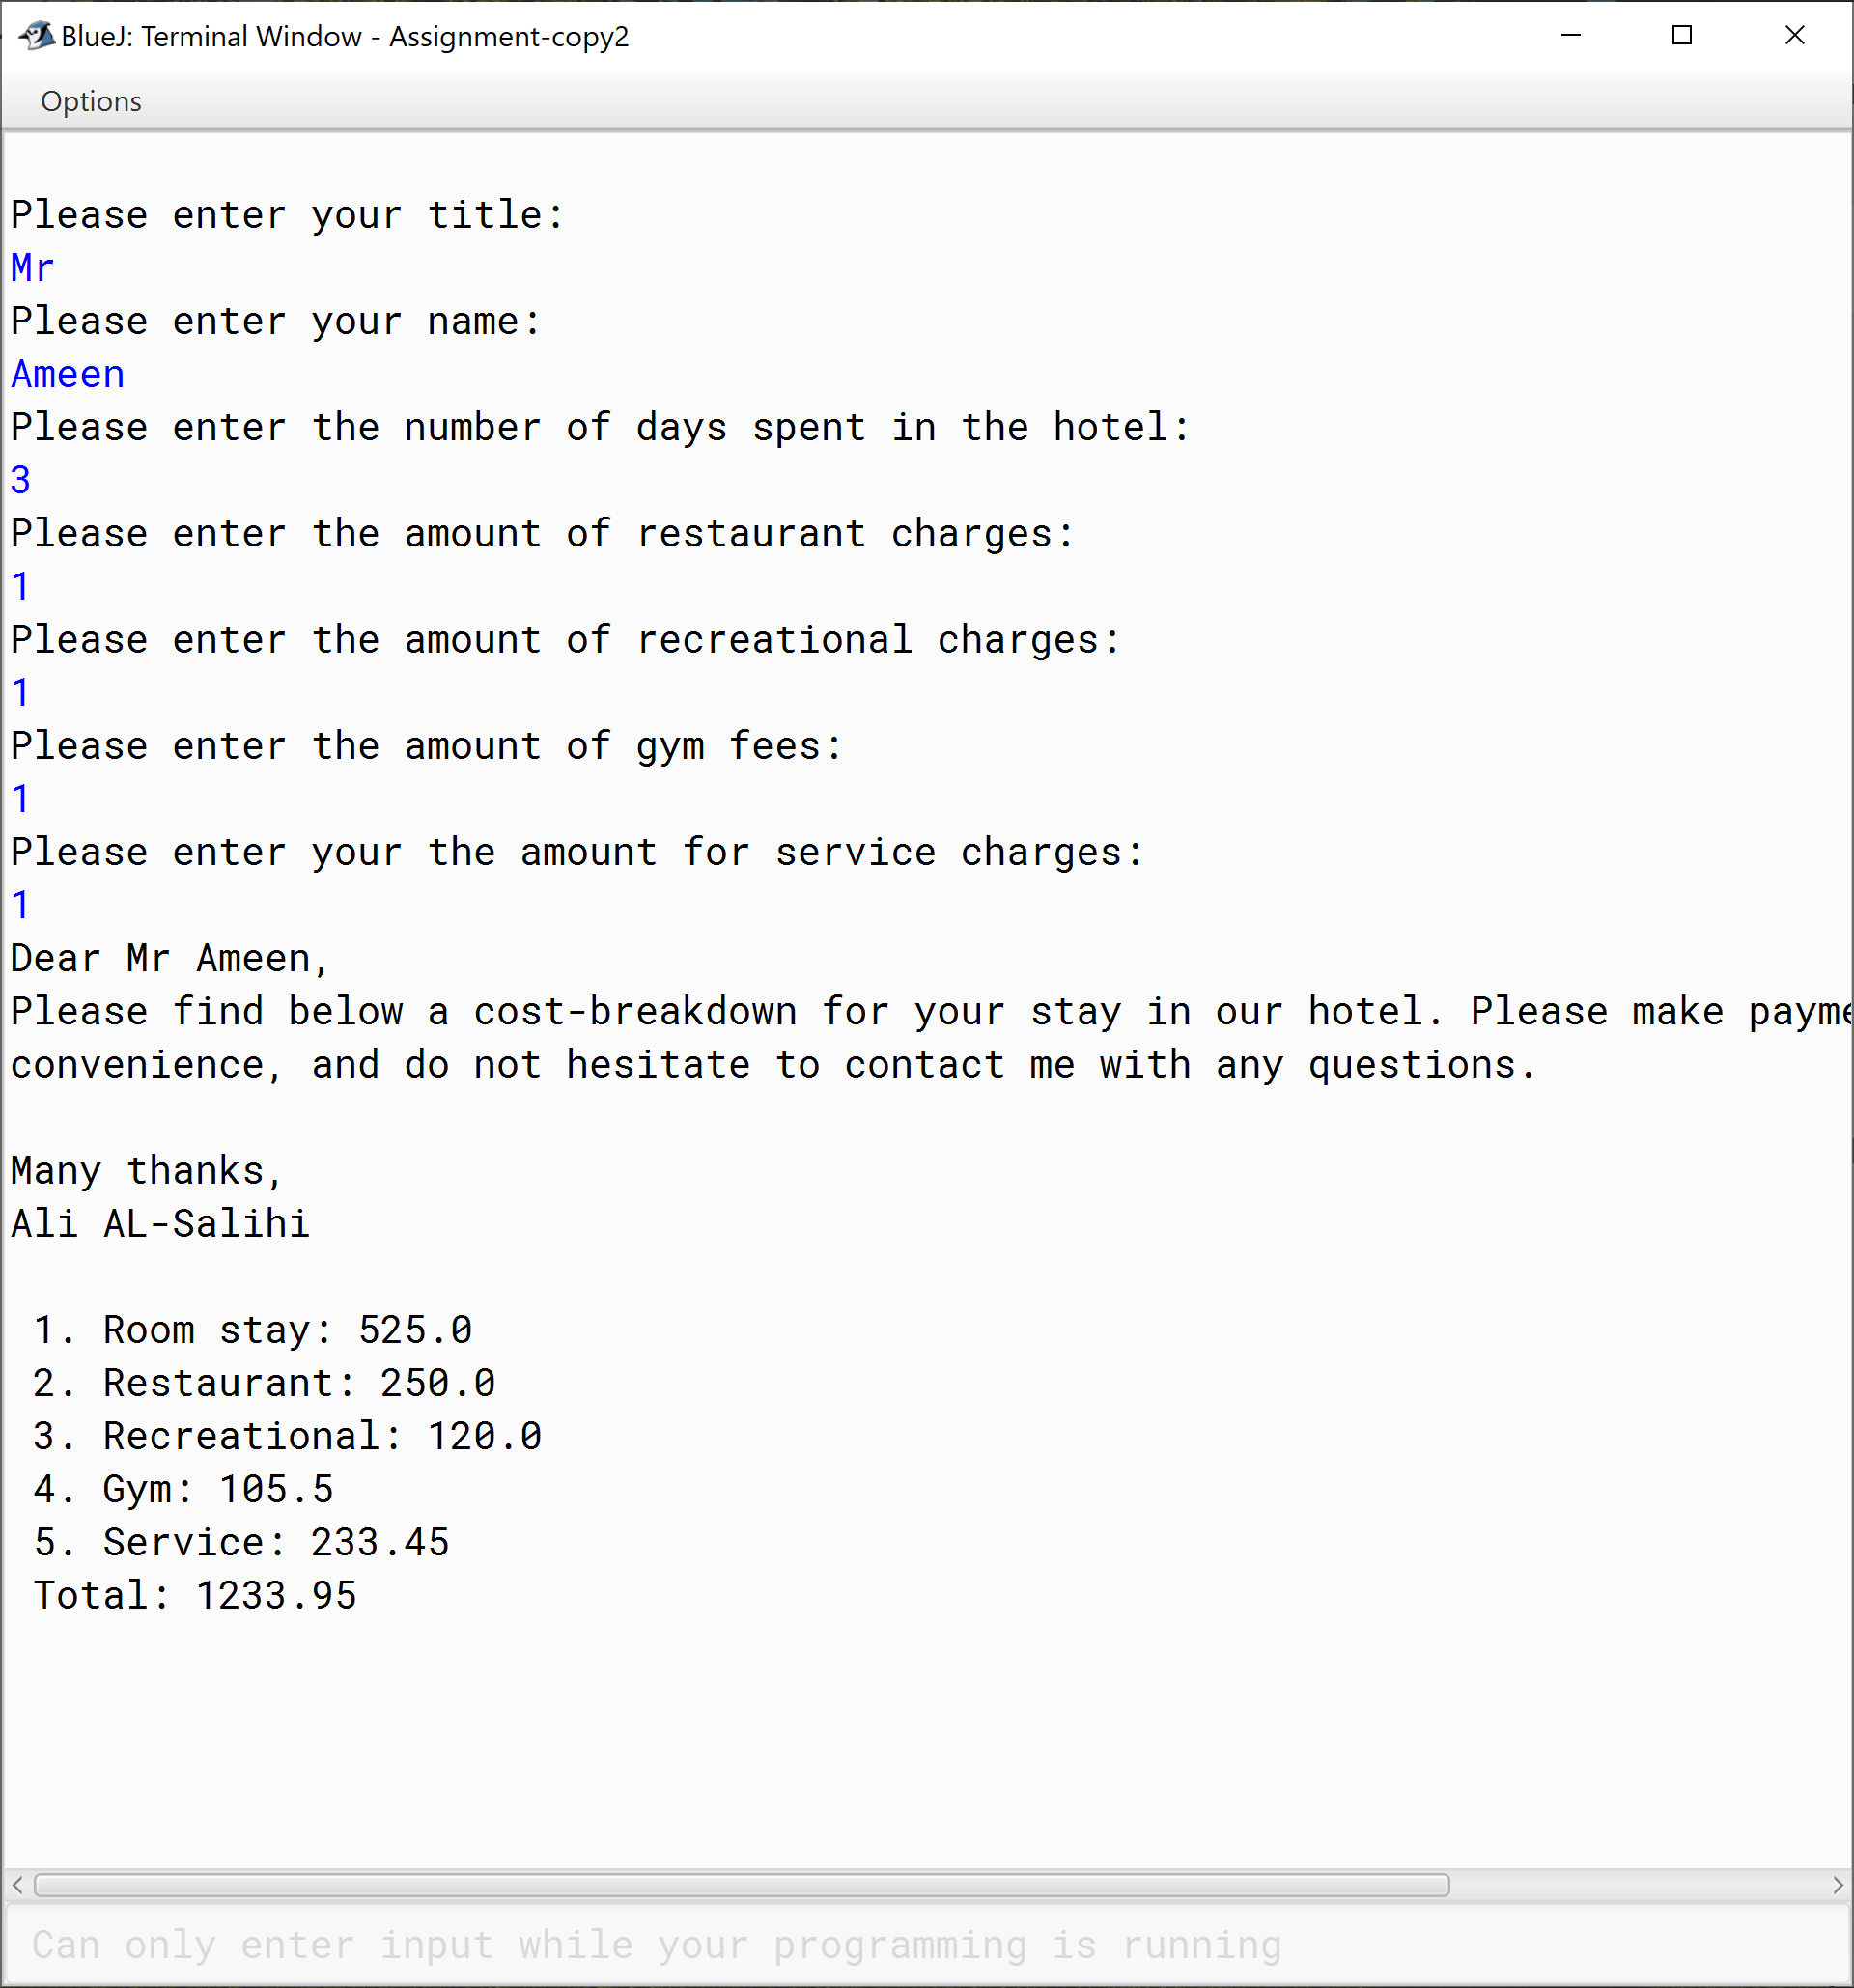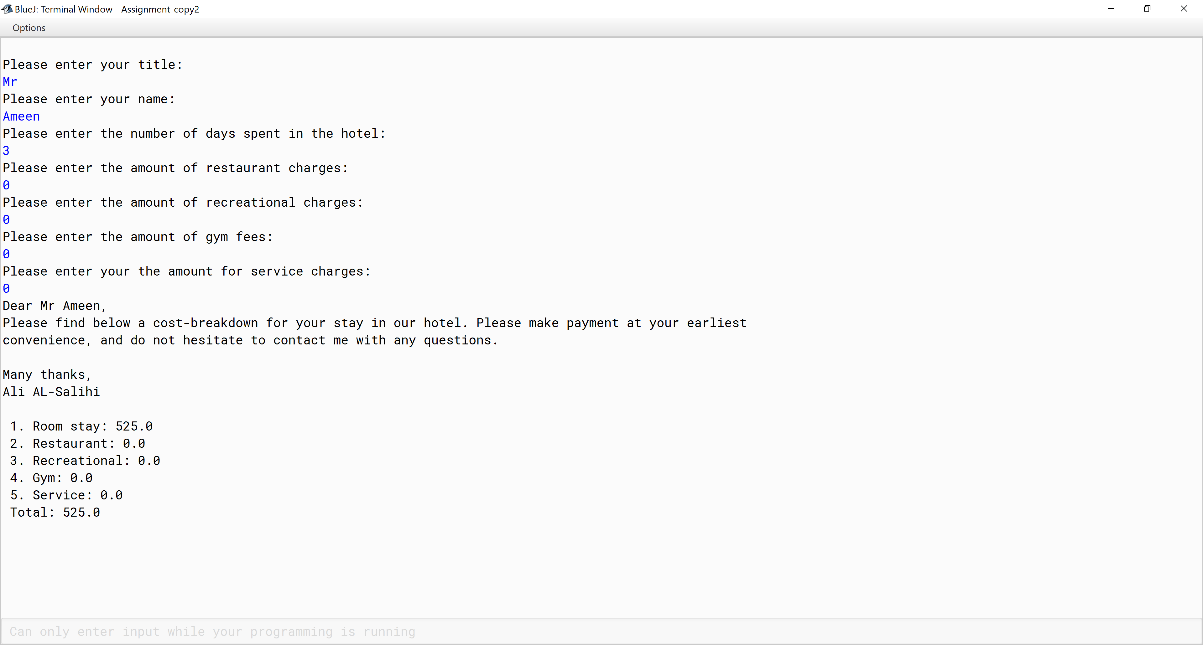

|  |  |  |  |  |  |  |  |  |  |  |
| --- | --- | --- | --- | --- | --- | --- | --- | --- | --- | --- |
| **Test Case ID** | | ARR_005 | **Test Case Description** | | Shapes numbers in square by the user’s row input. | | | | | |
| **Created By** | | Ali AL-Salihi | **Reviewed By** | |  | | **Version** | | 5.0 | |
|  |  |  |  |  |  |  |  |  |  |  |
| **QA Tester’s Log** | | N/A | | | |  |  |  |  |  |
|  |  |  |  |  |  |  |  |  |  |  |
| **Tester's Name** | |  | **Date Tested** | | 2020/08/21 | | **Test Case (Pass/Fail/Not Executed)** | | Pass | |
|  |  |  |  |  |  |  |  |  |  |  |
| **S #** | **Prerequisites:** | | |  | **S #** | **Test Data** | | | | |
| 1 | The user must enter their desired row number "Please enter the number of rows: “ | | |  | 1 | 2 | | | | |
|  |  | | |  | 2 | 3 | | | | |
|  |  | | |  | 3 | 5 | | | | |
|  |  | | |  | 4 | 6 | | | | |
|  |  | | |  | 5 | 9 | | | | |
|  |  | | |  | 6 | 13 | | | | |
|  |  | | |  |  |  | | | | |
|  |  | | |  |  |  | | | | |
| **Test Scenario** |  |  |  |  |  |  |  |  |  |  |
|  |  | | | | | |  |  |  |  |
| **Step #** | **Step Details** |  |  |  |  |  |  |  |  |  |
| **Step #**  1 | **Step Details**  The user must be asked to enter the number of rows | | **Expected Results** | | **Actual Results** | | | **Pass / Fail / Not executed / Suspended** | | |
|
| 2 | The user must be asked to input their last name | | A message to inform the user " Please enter the number of rows:" | | As expected | | | Pass | | |

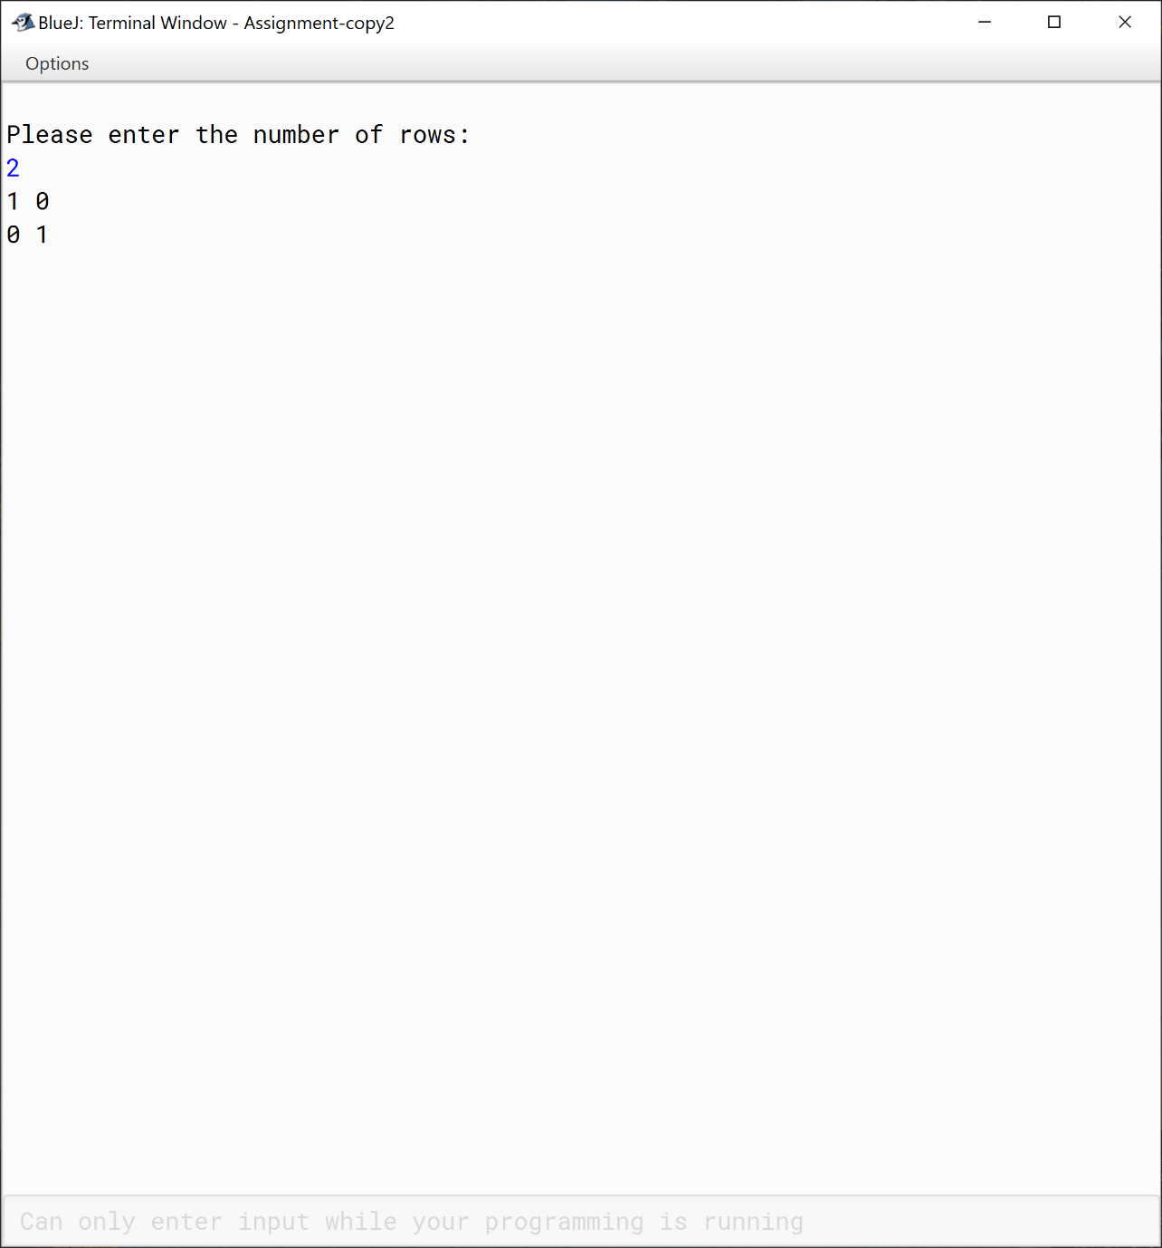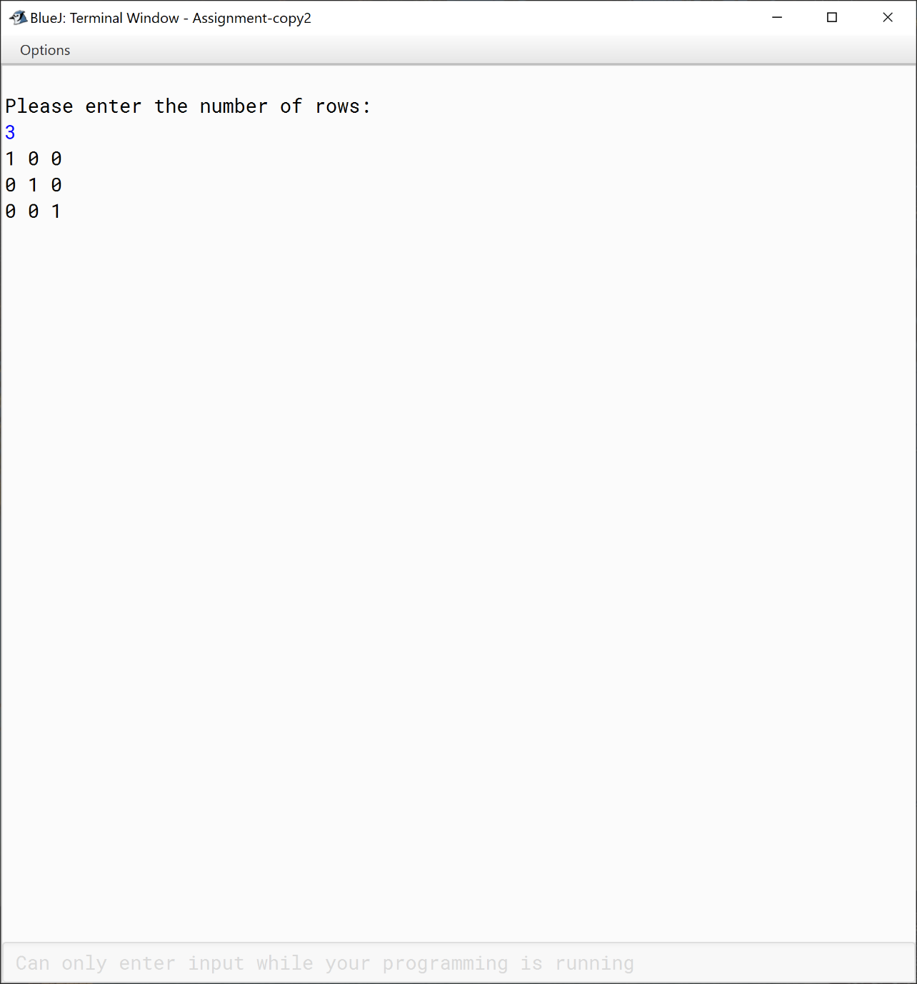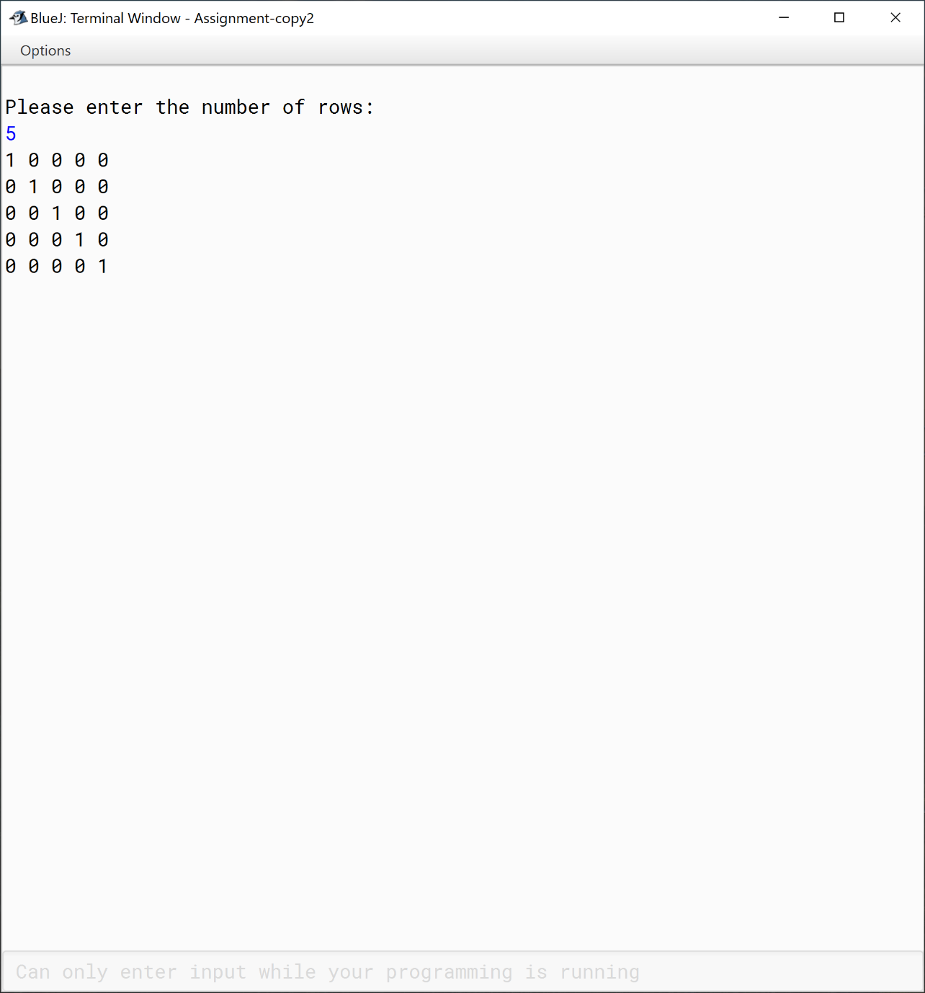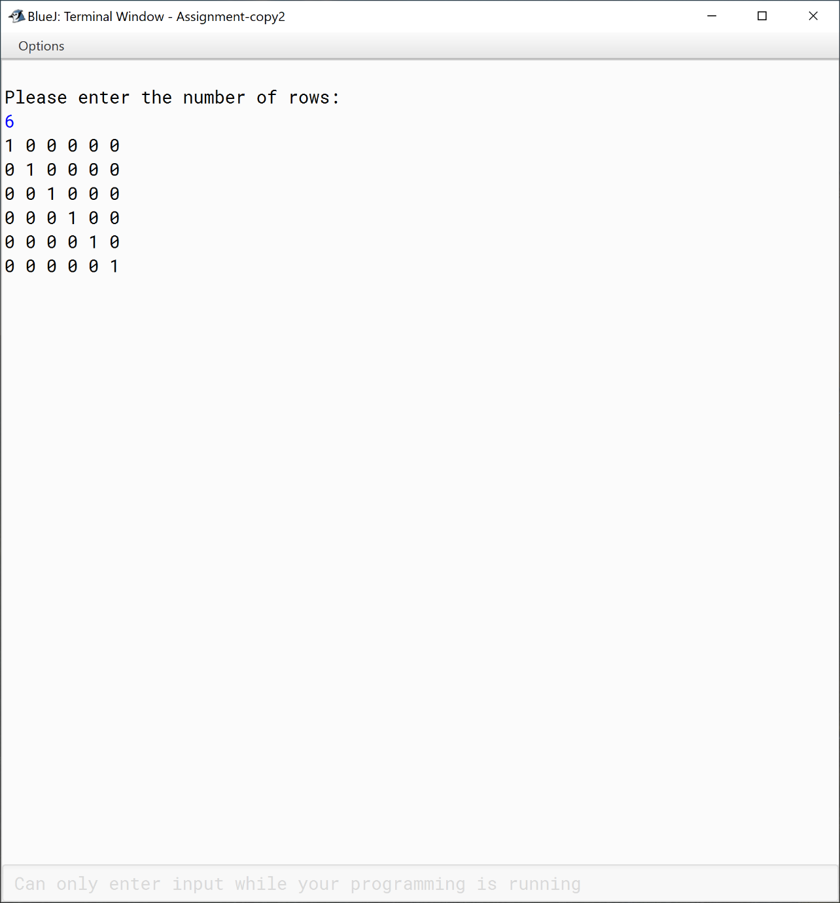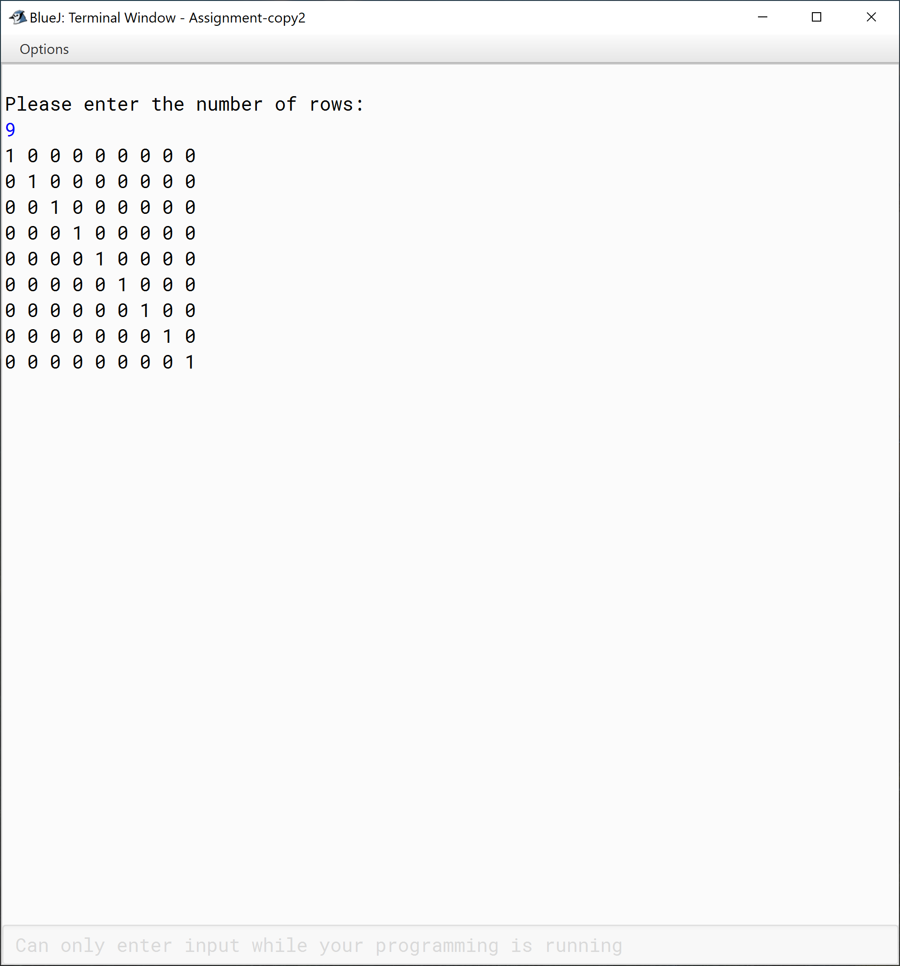

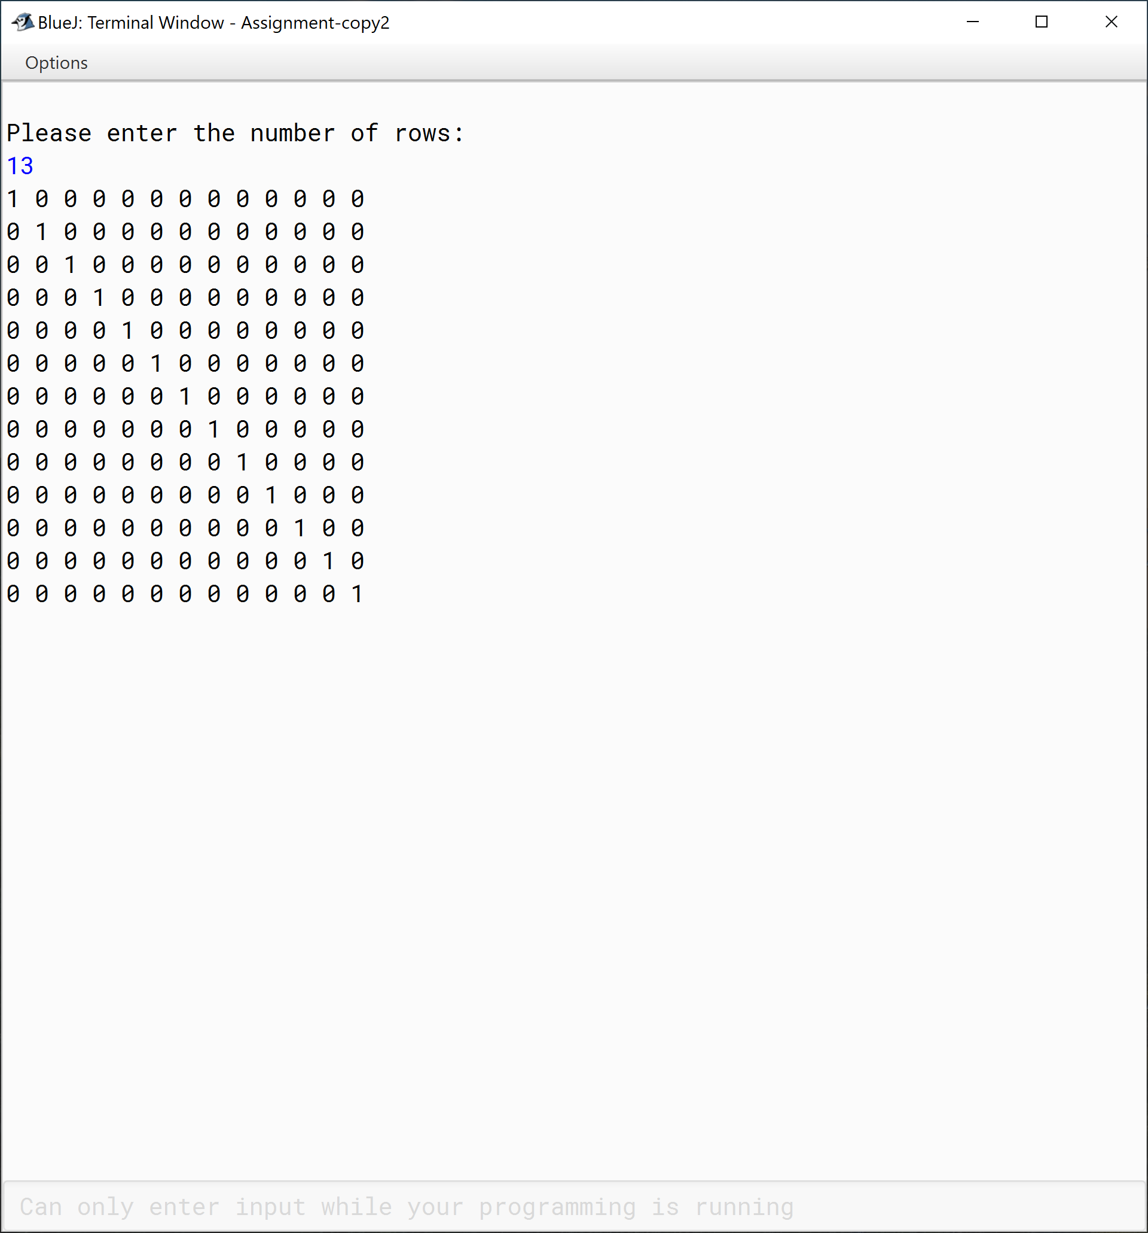

|  |  |  |  |  |  |  |  |  |  |  |
| --- | --- | --- | --- | --- | --- | --- | --- | --- | --- | --- |
| **Test Case ID** | | ARR_006 | **Test Case Description** | | Extracts story with removing the names | | | | | |
| **Created By** | | Ali AL-Salihi | **Reviewed By** | |  | | **Version** | | 6.0 | |
|  |  |  |  |  |  |  |  |  |  |  |
| **QA Tester’s Log** | | N/A | | | |  |  |  |  |  |
|  |  |  |  |  |  |  |  |  |  |  |
| **Tester's Name** | |  | **Date Tested** | | 2020/08/21 | | **Test Case (Pass/Fail/Not Executed)** | | Pass | |
|  |  |  |  |  |  |  |  |  |  |  |
| **S #** | **Prerequisites:** | | |  | **S #** | **Test Data** | | | | |
|  |  |  |  |  |  |  |  |  |  |  |
| **Test Scenario** |  | | | | | |  |  |  |  |
|  |  |  |  |  |  |  |  |  |  |  |
| **Step #** | **Step Details** | | **Expected Results** | | **Actual Results** | | | **Pass / Fail / Not executed / Suspended** | | |
|
|  | The file must be read by the program to process it | | To process a text file into a new file | | As expected | | | Pass | | |
|  |  | |  | |  | | |  | | |
|  |  | |  | |  | | |  | | |
|  |  | |  | |  | | |  | | |

